INTERNSHIP REPORT

ON



FAISALABAD

Submitted by:
ROLL NO:
SEMESTER:
SESSION:

DEPARTMENT OF MANAGEMENT SCIENCES
GOVERNMENT COLLEGE UNIVERSITY
FAISAL ABAD

DEDICATION

“I dedicate my report to my parents,
who prayed for my success
and to all my loved ones
whom i love from the core of my hearts.”

ACKNOWLEDGEMENT
All praises to Almighty Allah alone, the Most merciful and the most compassionate and His Holy prophet “ Muhammad “ (Peace be Upon Him) the most perfect and exalted one among and of ever born on the surface of earth, who is forever touch of guidance and knowledge for the humanity.
The work presented in this manuscript was accomplished under the guidance generous assistance, constructive criticism and enlightened supervision of Venerated Mr. Urfi Hashmi. His efforts towards the inculcation of spirit of constant work and the maintenance of professional integrity besides other invaluable words of advise will always serve as beacon of light through out the course. I take this humblest opportunity to my deepest sense of gratitude and thankfulness to him.
This internship report is not the result of individual effort. It is a result of wonderful team-work.
I am really thankful of Venerated Mr. Mohsin Cheema who is the Director of
MSC Textiles Pvt. Limited who gave me the approval for making of that regard. I am also really thankful of Venerated Mr. Zia Sb. who is the Assistant Admin Manager of MSC Textiles Who helped me for getting information about my internship.
I am thankful to all those who supported me and provide me great help for completion of this task. I have tried my level best to prepare this event with high level of accuracy but no one claim to perfect other than Almighty Allah.

EXECUTIVE SUMMARY

This report is the result of 8 weeks internship. During the internship it was required to study the organization, department of the organization and critically relate the theoretical aspects of the Marketing Department to the practical situation.
“SM Textiles Pvt. Limited” operates throughout the world with over 1200 employees as part of our team. SM’s Collection has a wide selection of quality Bed Linen, Kitchen Linen, Table Linen, Curtains, Slip Covers & All kind of Furnished Quilted Items, Flat Sheet, Fitted Sheet, Valance Sheet, Bed Ruffles, Pillow Covers, Pillow Shams, and Bolsters. Competent professional staff, a team of talented merchandisers, excellent supplies & support services, and state-of-the-art technology is the driving force behind SM’s phenomenal growth in the past years. SM has expanded its operations to include the Internet, and has taken advantage of the variety of international trade facilitated by the Web. Now SM uses state-of-the-art client/server technology for its market information processes to coordinate its network of global buyers and agents around the world. Environmental Organizational and the individual challenges which are to face by the department of “SM Textiles Pvt. Limited”. The motive of joining the SM is to have an exposure of textile sector and potential to avail a sound and promising career. There is no any formal union in SM Txtiles Pvt.Limited.

Table of Contents
Part # | Topic | Page #
1 | Introduction To textile Industry | 3
2 | Organization Background | 7
3 | Mission Statement | 9
4 | Customer’ Profile | 13
5 | Management | 14
6 | Responsibilities And Authorities | 17
7 | Field Of Activities | 20
8 | Production and Planning | 20
9 | Merchandising Department | 23
10 | Quality Assurance | 34
11 | Administration Department | 39
12 | Export Department | 47
13 | SWOT Analysis | 50
14 | Conclusion | 44
15 | Reference and Resources | 45

MISSION STATEMENT

“Commitment to quality, customer satisfaction and continuous improvements are the tools of our mission & success.”

MILLS & HEAD OFFICE LOCATIONS
M.S.C is situated on the following site and can be contacted on the contact numbers shown hereunder:
Location:
5KM- KHURRIANWALA, JARANWALA ROAD,
FAISALABAD,PAKISTAN.
Contacts:
+92(41) 4363811-20,
Fax :- +92(41) 4360705
Chief Executive Officer
MR. MUSHTQ ALI CHEEMA
Voice direct : +92(41) 4363820
Mobile : 0300-866224
Email : ceo @msc-textiles.com,
City Office
P-19 1st Floor, Montgomery Bazar, Faisalabad, PAKISTAN
Voice : +92(41) 644577,611553,
Fax : +92(41) 62849

ORGANIZATION BACKGROUND

The M.S.C. TEXTILES Pvt.Ltd. was established in 2002. The overall management is in the hands of the owner, "The Technical Director", of the company, who is controlling as well as analyzing, manufacturing and administrative affairs of the project. Textile is the most important industry in Pakistan. Pakistan’s textile industry based on locally grown cotton produces like cotton cloth, and made-ups textiles and apparel.

ORGANIZATION CHART
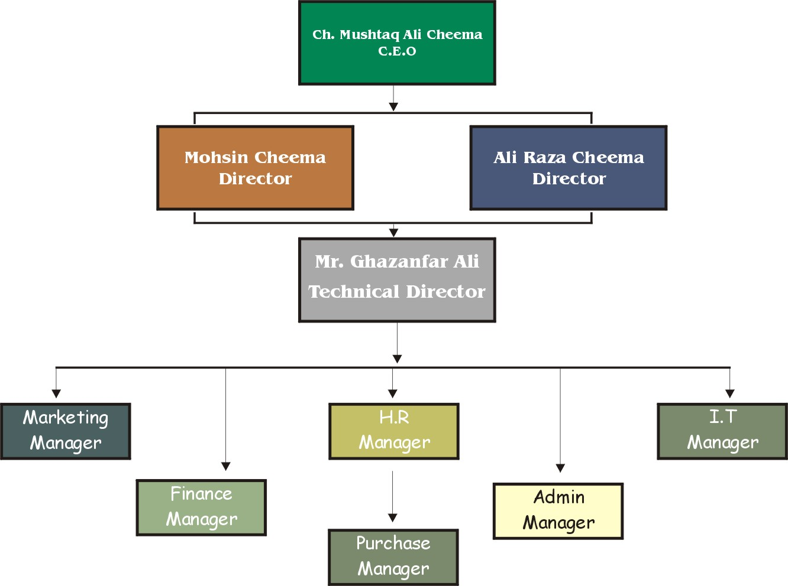

ORGANIZATION DESIGN

To understand the various ongoing activities, tasks, technology, environment and goals of M.S.C. TEXTILES Pvt.Ltd. I analyze it as under i.e.

Formalization:
M.S.C. TEXTILES Pvt.Ltd. is a large and complex organization that follows different rules and regulations for governing the whole system of organization. All these rules and regulations have been documented to enhance the efficiency of the organization. The list of important documents that I observed during my internship is as under:
- Initial Screening and Bio-data Form
- Job Description
- Job specification
- Employee’s Handbook
- Employee’s Evaluation Form
- Internship Rules and Regulations Forms
- Internship Evaluation Form
Specialization:
M.S.C. TEXTILES Pvt.Ltd. have different specialized departments to subdivide different specialized tasks into different categories. The function of each department is to concentrate only on specific task to enhance the work efficiency of the department. Following specialized

Departments are working these days in the organization:
- Human Resource Management
- Administration
- R&D Department
- Labs
- Finishing
- Management Information System
- Processing
- Merchandising
- Sampling
- Grey Fabric Store
- Chemical & Dye Store.
- Export Department
- Finance
- Dyeing
Standardization:
Standardization means the similar work activities performed in a uniform manner. So M.S.C. comes into highly standardized organization because work contents of every department have been described in detail and all departments have similar objective i.e. enhancement of quality and customer satisfaction. So similar work is done at all locations.
Hierarchy of Authority:
This clearly tells that who reports to whom and the span of control of each manager as shown in the organization chart. Up to directors level, the hierarchy of authority of M.S.C. is shorter but on the middle management level, the span of control is narrow and hierarchy is tall.

Complexity:
M.S.C. has vertical and horizontal complexities but no spatial complexity because the organization is located at one place but it has many major department and many more job titles.
Centralization:
All decisions are made with the permission of top management. So it has influence on all types of decisions. It means it is a centralized organization.
Professionalism:
In this area M.S.C. is rich. Human Resource Department has recently introduced training programs for department managers and for all other employees to familiarize them with the on going changes. They are determined to achieve specific level of training necessary for all.
Personnel Ratio:
It is obtained by dividing the number of employees in a classification by the total number of organizational employees. As in M.S.C. the total number of employees are more than 1200. But the numbers of employees working in different departments are different. For example in Marketing 17 people work whereas in R&D 3 people work. So personnel ratio is different for different departments, somewhere high, somewhere low.

Size
More than 1200 employees are working these days in M.S.C. It has different target markets in different foreign countries as specified in internship report. So its total sales are also very large. It has a single place of working but it occupies large area. Hence the size of M.S.C is large.

Organizational Technology
M.S.C consists of highly standardized and technical equipments, latest dyeing, knitting and finishing machines, fully equipped labs, internet and intranet facilities, and MIS department. So it has latest state of art organizational technology.
Organizational Environment
The environment of M.S.C is friendly at most of the places but lower level workers are not satisfied with the harsh behaviors of the managers. So it has a large pool of unmotivated employees. Any change in the organization is made welcome strictly by the top management.

Goals and Strategy
Like any other large organization, M.S.C has specific goals:
- Development of a creative and skillful management.
- Achieving zero defect workmanship.
- Meeting delivery commitment.
- Buyers’ confidence and satisfaction.
- Employee’s participation and growth.
- Quality assurance.

Culture of M.S.C TEXTILE Pvt. LIMITED
I observed two important things in the culture of MSC :
- Internal integration
- External adaptation
Internal integration in the sense that MSC has specific work pattern, ceremonies, symbols and traditions that they teach every new entrant. External adaptation in the sense that M.S.C is adapting new strategies and techniques e.g. computer-aided-design, internet, intranet and establishment of different departments like Research and Development(R&D) and Human Resource(HR) to compete efficiently with its competitors.

PURPOSE OF REPORT

By definition internship is a working program arranged for gaining experience. After completion of 21 compulsory courses for MBA the students of GOVT. COLLEGE UNIVERSITY FAISALABAD are required to undertake training in an organization selected by them, for a period of 6 weeks. The internship enables the students to understand how the theoretical portion of their studies can be applied to the practical situations. After gaining experience in an organization, an internship report is prepared. A copy of the internship report submitted to the organization studied must also be provided to the DEPARTMENT OF BUSINESS ADMINISTRATION. This report is a compulsory requirement to appear in viva voce, which ultimately fulfill one of the basic requirements for obtaining MBA degree.

Business Operations
Stitching:

- Single Needle Juki
- Over Lock Pegasus
- Kansai Special
- Button and Button Hole Set
- Double Needle Lock stitch
- Four needle Lock Stitch
- 12 needle Chain Stitch
- Blind Stitch
- Steam Boiler press unit
- Stripping Machine
- Cutter
- End Cutter
msc Textiles owns more than 350 stitching machines, including specialized automativ attachment machines, two multi-needle quilting machines, four fingle-needle quilting machines and two warding plants. We use the highest quality materials and components for manufacturing our products. Our equipment is subjected to a thorough quality control program. Each and every product is quality tested by stringent guidelines to ensure that international quality standards are met.
Weaving:

- Sulzer
- Jacquard Punching Machine
- Wrapping
- Sizing
- Rolling
- Folding
- Power generating Unit

More than 20 years ago MSC Textile started as weaving company but now MSC is leading exporters of quality textile goods. They reach this level by longevity and adopting the latest technological advancement in the industry. MSC weaves stains, percales and most kind of fabrics from 35” to 153” under the MSC umbrella. MSC contract higher and supervise more than 200 sulzer and air jet looms.

Machine capacity:

Machine | Number | Width
Power looms | Over 100 | 76” to 120”
Auto looms | Over 450 | 35” to 120”
Sulzer looms | Over 100 | 110” to 153”

Singeing:
Msc textiles is successfully processing materials in state of the art Osthoff singeing machine imported from Germany. This cutting edge technology enables us to process 100000 meters of double sided singeing for width 126 in just 24 hours. This machine provides a variety of singeing positioning as well as variations of key singeing parameters like speed flame intensity and distance of the fabrics from Burner. These controls are readily adjustable and monitored by professionals who enable the process to be the most precise and easy to reproduce.
Design Studio:
Msc Design Studio plays an important role in the printing process. Its staff is comprised of creative and talented textile designers, skilled graphic artists, and engravers. Our studion has earned a top-notch reputation of efficiently providing optimal results in creation, color separation, coloration and image processing of textile designs. Modern studion equipment and advanced tools like stork best-image software further enhance our capabilities to provide precise and speedy workflow. This automation has resulted in the reduction of total production time for studio work, more accurate printing results, and in the increase of production management functionality.

msc has in house designers are working round the clock, making new and creative designs, keeping in mind different world markets. This has enabled us to offer our clients with a wide range of designs for their market.
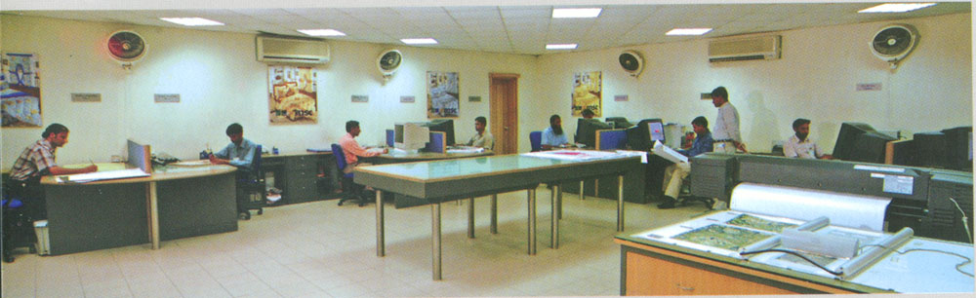
To achieve every detail of the design MSC have two of the world’s best computerized (Best Image Software) ngraving machines, Stork (Mask Exposer).
Printing Facility:
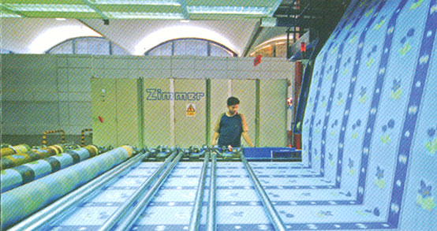
Msc Textile provides precision printing on any fabric. Msc uses Zimmer Rotary machines, which provides perfect, repeat and registration control as well as precision printing. The machine handles up to 16-color printing with a maximum width of 126” and a maximum printing speed of 120 meters / minute with the total capacity of 3 million meters a month. Every design is run under strict supervision of quality department from registration to the colour matching all is carefully monitored.

Machine Capacity:

Machine | Company | Country | W/width | M/24 HR. | Performance
Rotary | Zimmer | Austria | 126” | 60,000 | 16 Screen
Strike Off | Zimmer | Austria | 126” |  | 16 Screen
Curing | Sitara Eng. | Pakistan | 115” | 60,000

Dyeing:

MSC have recently installed dyeing unit with one thermosol and pad steam dyeing. Both machines are equipped with Kusters Padders to achieve even and continuous dyeing. Together the machines have a monthly capacity of 1 million meters.
Finishing:
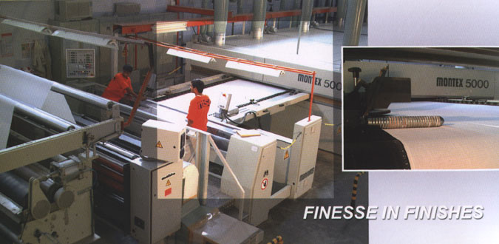
For Batching and Finishing MSC finishing plant employs the latest stenters from Monfort Montex Company (5-9 chambers) with weft straightener fro Mahlo. The digital Mahlo system enables to control cross bow and skewing in fabric, which is essential in printing geometrical designs. MSC apply special finishes.

EMPLOYEE’S PROFILE

The secret of success of every organization is the result of the commitment, dedication and team spirit of its employees. M.S.C. is no exception employing over 1200 people, including more than 100 professionals. M.S.C enjoys high employee motivation and excellent working standards by encouraging informal and frequent communication at all management levels. People are expected to take full responsibility for a job and get it done. It is a matter of pride for M.S.C that it enjoys one of the lowest employee’s turnovers in the country. The factory works for three hundred sixty five days in a calendar year with twenty four hours daily, in three shifts.

ORGANIZATIONAL POLICY

“The management and employees of MSC are committed towards utilization of all available resources to provide such products that are technically complete, professionally done, reasonably priced and delivered on schedule, in a way that exceeds customer expectations.”

QUALITY POLICY

“Production of products according to the needs and expectations of customers is quality. MSC Textile (Pvt.) Limited achieves quality objectives through professional management, skilled workers and modern machinery. The company management as well as workers are committed to continuous improvement in quality of grey cloth, finished fabrics and textile mad-ups with timely delivery.”
OUR MOTTO_______ Excellent Quality

SOCIAL POLICY

“We the top management of MSC Textiles (Pvt.)Limited strongly believe in the supremacy of social norms and values and our all workers are given respect, integrity, freedom and are considered our partners.
We work in complete compliance with SA8000 Standard through continuous improvement.”

ENVIRONMENTAL POLICY

“We are committed to maintain pollution controlled, Environment friendly and legally compliant working environment and strive to make it better via continual improvement and pollution prevention.”

COMMITMENT TO QUALITY.

Quality has been slogan of MSC to help and achieve goal have different crosscheck systems to maintain the quality standards. At processing MSC have sophisticated and full equipped quality control lab (QCL) which administers quality from the issuance of the fabric till finishing. While checking the quality of fabric, customer standards are carefully documented and administered. After processing, each and every meter of fabric is physically checked to make sure that the fabric supplied is up to the ark.
For fulfillment of this commitment:

- We are adhering to Quality System by preferring prevention over correction.

- The proper training of our personnel is our top priority in order to keep them in-touch with new ideas and innovative techniques of production.

- We are emphasizing on customer satisfaction because customer is our master.

- We ensure continual improvement of our process and system to produce consistent quality.

Quality Management
In the line with our basic philosophy, we believe that our future depends on our ability to consistently produce only the highest quality products. Effective quality management is therefore a basic necessity and hence top priority. Fabrics off all ding in variety of constructions are supplied overseas.

The company has the capacity to meet orders large quantities out of its own production. The balance requirements, if any, are met by procurement from the preferred suppliers. The quality thus procured is, however, put to tight inspection, ensuring that compromise is made.
The company maintain strong network enabling best possible combination of pricing and availability to the entire satisfaction of its buyers.
An independent quality control team is trained specially to monitor each process to ensure the customer’s requirement. It is a flit team with authority to control complete production processes to achieve the desired quality level.
Each and every material used is checked by this team before it can be stored or consumed.
Process of quality checks starts from in-house fabric, inspection, cutting, inline and final inspection in sewing and wet process, finishing till the end when the final product is packed for shipment.

“Without comprising on quality, we achieve our production targets”.

Quality Assurance
The management is ever conscious about quality of the company’s product. Accordingly the company has established its own LAB equipped with modern apparatus and qualified technicians. The tests carried out in the LAB include analysis of the fabric pilling, color fastness, rubbing fastness, light fastness, shrinkage, blend ratio etc.

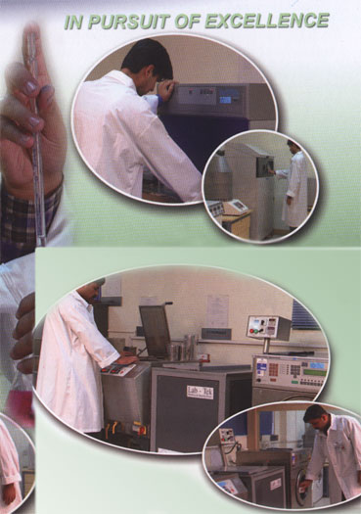

SWOT ANALYSES

Strength

Imported Machinery

Strong Marketing Image
- High Financial Resources

Awareness of Product
- Committed Staff
- Good Reputation

Weakness

- Weak implementation for Production Planning
- Delay in Out side Grey sourcing
- Decision making power is centralized
- Slow process for development of new items/inquiries
- Product range display room need improvement
- Minimal meetings between export & production departments

Opportunities

- Potential in Market
- Covering almost all areas of the world
- Untapped market of Russia & Middle east

Threats
- New Entrants
- Tough Competition
- Strong Promotional activities to convince buyers by competitor
- Uncertain Political and Economic condition

MARKETING DEPT.

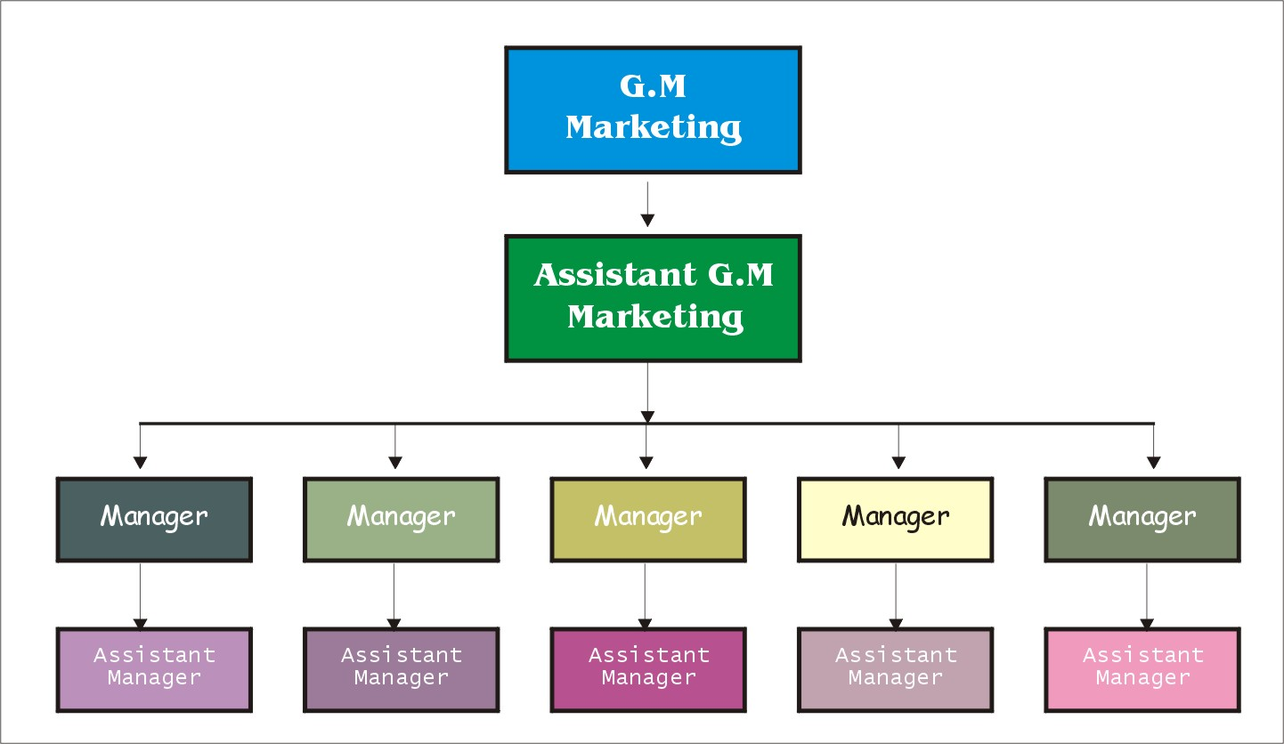
Marketing Department:
Marketing Department cannot be ignored in any organization. Because it is the heart & soul of the organization.
MSC Textile cannot ignore the pivotal importance of this department. The marketing manager with the Chief Executive Officer performed the marketing activities jointly. They not only promote their department but also visit the foreign markets to search their new markets.

Marketing Strategy

- Maintain high standards
- Develop and strength good business relationship with the valued customers
- To maintain timely deliveries
- Search for and introduce latest technical and design developments
- Search for new markets
- Strive for expansion in the local and international markets.
Our marketing team comprises of top of the line individuals who are fully capable of achieving sharp deadlines. These individuals are highly trained to develop and maintain excellent business relations with the existing customers and are always in pursuit to look for new markets.

EXPORT

Vision Without action is a daydream; Action without vision is a nightmare

Marketing:
“Marketing is a process of planning & executing the conception, pricing, promotion & distribution of goods, services and ideas to create exchanges with target group that satisfy customer & organization’s objectives”

Marketing Concept:
The marketing concept holds that the key to achieving organizational goals consists in determining the needs & wants of target market & delivering the desired satisfactions more efficiently than competitors.
It can also be expressed in many other ways like
- Meeting needs profitably
- Find wants & fill them
- Love the customer, not product
- To do all in power to pack the customer’s dollar full of value, quality and satisfaction
Export means to sell the products outside the boundaries of the country.
Marketing Division deals with market activities related to product sales abroad. MSC products are Grey cloth, Bleached, dyed, printed fabric and made ups (Home furnishing items). MSC is famous for its quality products and its products are exported all over the world.

Objectives of Marketing/Export Dept.
Following are the main objectives of export dept

Committed to generate export business all over the world with good quality products.

To provide better service to customers
- To achieve company objectives actively

Establish & develop professional working environment in the Dept.

Computerize work in Export Marketing Dept.

Incline a sense of responsibility and timely initiative in staff members of Dept.

Proper implementation of ISO 9002 standards

EXPORT ORDER EXECUTION

Inquiry by Customer:
Customer inquiries are received via fax and E-mail. Inquiries that comes through Fax are directly received at fax room and sent to CEO as well as concerned department, however inquires through e-mail are directly received in concerned dept.

Costing Sheet:
After receiving inquiry from customer first of all costing sheet is prepared for price determination. CEO is final authority to finalize the price to be quote against any inquiry, however in absence of CEO export dept. incharge reviews price idea. If both are not available, then sectional incharge is allowed/authorized to quote price.
After approval of price and review of customer's requirements, prices are quoted to customer for confirmation. Upon confirmation, sales contract is issued to customer with complete details of constructions, width/size, prices, quantity, delivery, payment terms etc.

Contract Review & Issue:
Sectional incharge takes following steps before issuing a contract:
- Complete review of the contract
- Whether requirements are adequately defined.
- If have the capability to meet the order requirements/ Shipment date

Purchase Orders:
Purchase orders are received from customer pertaining to contract booked. Sectional incharge studies it for any discrepancy or any special instruction. If there is any discrepancy it is brought into the knowledge of customer for amendment. However, if customer wants to amend the contract booked, after considering all the aspects of the order it is amended. Instructions of amendments are passed to relevant departments to follow.

Greige Demand:
- To Export Sale (ES) section for any new order.
- To production planning & co-ordination (PPC) section. They are responsible to co-ordinate between export & processing dept.
- To stock management for updating stock position within the mills.

Strike Off / Sample approval:
Usually customers send their designs artworks. These designs can either be on paper sketch or fabric cutting. As per customer requirement strike off is prepared for customer approval. If strike off is approved customer gives the assortment/quantity required for printing of concerned design. In case, strike off is not approved new strike off sample is prepared keeping in view the discrepancies pointed out by customer. If there are miner changes that customer points out then mostly its done during bulk production rather than preparing new strike off sample.

Assortment:
Once customer is satisfied with the strike off, the order quantity is assorted with design / color ways per width / size item.

Processing / Garments Instructions:
On receipt of assortment instructions are passed to processing dept. for processing of goods. In case of Made-up orders garments instructions are also passed to garments dept.

Letter of Credit (L/C):
Customer opens L/C well before shipment. In case of any delay in receipt of L/C concerned sectional incharge reminds customer.

On receipt of L/C it is checked in regard to ordered goods, price, shipment details, markings, shipment negotiation details etc., by the sectional incharge. If there is any discrepancy in L/C then it is informed to customers for rectification accordingly.

Goods in Process:
As per customer’s requirement, the fabric is bleached, dyed, printed, finished and sent to the folding dept. for packing and onward dispatch. Incase of M-ups order, the finished fabric is sent to garment section for stitching of the M-ups product.

Dispatch of Goods:
Packed goods details along with sample sent to each export section that verifies quantity of goods to be dispatched. Export section intimates S&D section to dispatch the goods. Before dispatching the goods production sample is checked by export department. These goods can be dispatched in following two ways
Through dry port
Direct to Karachi
Dispatched goods details are noted in relevant registers accordingly.

Shipments:
S&D dept. is responsible for all documentation & shipments.

SAMPLING UNIT

M.S.C. TEXTILES (PVT) LTD. has a fully computerized sampling unit with over a dozen of latest high speed computers and electronic accessories to facilitate departments, equipments and processes and procedures and is managed by high level professionals and competent people. Employees always remain committed to work round the clock to meet the shipment deadlines.

PRODUCTS
M.S.C produces following type of products in an efficient and effective way:
Greige:
- Power loom fabric (COTTON, PC, CVC)
- Auto loom fabric (COTTON, PC, CVC)
- Suttless loom fabric (COTTON, PC, CVC)
- Plain, twill, drill, sateen, dobby, oxford, bull denim, reverse sateen, poplin

Fabrics:
100% Cotton & Poly Cotton (all Sort of Blend Ratios) in Grey, Bleached, Dyed & Printed.
Made Ups:
Bed Linen, Kitchen Linen, Table Linen, Curtains, Slip Covers & All kind of Furnished Quilted Items.
Bed Linen:
Flat Sheet, Fitted Sheet, Valance Sheet, Bed Ruffles, Pillow Covers, Pillow Shams, Bolsters, Embroidery Quilt Cover Set.
- Quilt Covers And Comforters.
- Table Covers/Napkins.
- Sofa Covers.
- Curtains.
- Kitchen Linen/ Accessories.

Product Range:
MSC have value added product range includes sheets sets/ duvet sets, embrodied sets (accessories) curtain/ draperies, bed in a bag, mattress protection and a wide range of hotel and health care products.
Product innovation and development is a continuous process for us.

 |  | 
 |  | 
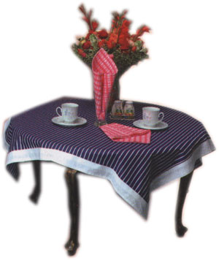 |  | 
 |  | 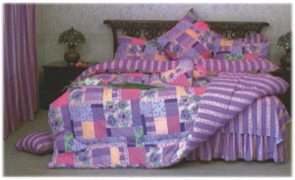

MSC TODAY AND TOMORROW:

MSC future plans are no different than past. MSC have double capacities and sales over a period of one year. They have been able to vertically integrate more that ever before.
They are in process of installing a spinning unit, which will make us a composite unit. Other future expansion plans include an air-jet and a flat bed printing.

Bottom of Form
AWARDS & HONORS

- Recipient of “Export Merit Trophy” fro Federation of Chamber & commerce of Pakistan (Last several years).
- 2nd largest exporter of cotton fabrics to quota countries from Pakistan by Export Promotion Bureau (1999). MSC are ranked among the top gfive fabric quota holders for the United State.

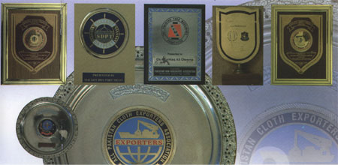

SUGGESTIONS FOR IMPROVEMENT

Compensation policy:
It has been observed that the compensation policy is not perfect. First of all there is no proper pay scale according to the hierarchal structure of the organization. I found that one manager is earning e.g. 35000 and other is earning 9000. There should be a systematic way to create a pay scale. I am also of the view that for the motivation of the employees it is necessary to give continuous compensation packages. (Bonuses, increments).
Equal employment opportunity:
It is also observed that the concept of gender bias and class ceiling is prevailing in M.S.C. because I have not seen even a single woman working at the higher management or even at the middle management. It is not suitable for an ISO 9001:2000 certified company to continue this behavior.
Job rotation:
This is a tool used by the human resource management for the purpose of adjusting employees in different departments to meet the emergency. Different number of staff require to be rotated on different jobs to diversify their skill and enhance their visions.

Job security:
It is the duty of the management to provide job security to the employees. Here situation is that in front my eyes two employees left the organization only for the reason that they were not feeling job security.

Right man on the right job:
I observed that in M.S.C. the principle of right man for the right job is not implemented. I witnessed that a person who was MBA with a specialization in finance is working in the production department. And many other examples. So in this regard top management and human resource department should have to take effective measures.
Flexible working hours:
In M.S.C. I saw that a term used “Aanay ka waqt tu 8:30 hai laikin janay ka koi waqt nahi”. Flexible working hours are very necessary to improve the working of the employees. So I think management should take effective action regarding this problem.
Factor of motivation:
To see the success of an organization it is necessary to check that up to what extent its employees are motivated. But, unfortunately, in M.S.C. the ratio of unmotivated employees are very high. And it is the responsibility of the management to eliminate the problems.
Elimination of interdepartmental politics:
I also found that there were some departments where political culture was prevailing. However, it is the fact that if someone is taking your authority then you would not like him. But in organizations, this type of culture should be eliminated.

Effective audit:
I personally saw the monthly audit in main store. I think it may be more effective by taking some steps. Because accountability makes the employee working with their full devotion.
Arrangement of extra curricular activities:
Extracurricular activities should be carried out by the HRD for the refreshment of the employees working in the organization. Transportation:
I appreciate the steps taken by the HRD regarding the facility provided to the employees who come from different locations. But I think that there should be new routes to facilitate the new employees.
Supplier’s satisfaction:
I found that different suppliers working for the M.S.C. are satisfied in terms of their in time payments but they are of the view that their receiving system is not effective. So for the satisfaction of the suppliers their suggestions should be brought under consideration.
Control on strikes:
Every body knows that strikes are very harmful for the textile units. It not only stops the production but also creates a bad image not only on the buyers but also on the suppliers and all the stakeholders. So it is the responsibility of the top management to prevent and take immediate actions to stop this type of problems.
In time payments:
I found that M.S.C. is very popular on account of it’s in time payments to the employees and suppliers. We really appreciate this policy of the finance department and suggest to continue this routine.

In time communication of job description:
Job description means that what are the requirements to fulfill a particular job. So it is the responsibility of the human resource management to prepare a job description of all the jobs or designation working in the M.S.C. And this should be properly communicated to the employees at the time of their recruitment that what are the expectations of the organization from them.
Training programs:
Continuous training programs should be carried out by the HRD to keep employees in touch with the new technologies and changes in the textile Industry.
Proper performance appraisal:
The primary goal of an appraisal system is to improve performance standards. So continuous performance appraisal process should be implemented in the organization to check the performance of the employees. And then take steps according to the results, because it is not the right way to fire any employee at any time without any particular reason ignoring his past experience and his devotion towards the organization.
Implementation of HR policies:
Employees working in M.S.C. are of the view that the progress of HRD is only in the papers. However this statement by the employees is not right because we personally viewed their working and their progress e.g. beginning of transportation system, training programs. But it is necessary for HRD to improve its image for the employees. Because the more the HRD is employee friendly the more this department can produce effective results.

Suggestion boxes:
I observed that in every department suggestion boxes are fixed in the walls. But, unfortunately, no body knows their importance. It is also observed that these have not been fixed on the proper places. I think that if HRD properly rearrange these suggestion boxes and create awareness among the employees about their importance then it can be very beneficial for the management.
Dispensary & First aid boxes:
The working of the dispensary is satisfactory but there is no in time delivery of the medicines. On the other hand the first aid boxes are used for keeping stationary and other waste materials. I think that there is a need of giving importance to these problems.

CONCLUSION

M.S.C. TEXTILES (PVT) LIMITED has got the favorable opinion of the masses and is considered as efficient as one could be and the best manufacturing factory in the locality. M.S.C. TEXTILES (PVT) LIMITED, not only in the minds of customers but all over the international markets, have successfully developed and created positive and very good corporate image.
Although there is a tough competition in the international market but M.S.C. products, curtains, bed linen & gray cloth are continuously going on its way to prosperity. Main customers of the company are all over the world. This is all on account of the high quality products of the company. Company’s quality assurance department is so well established that some times the customers request the company’s quality inspectors to visit to some other companies where their other products are being manufactured, so that the quality of that company can be checked.
Major countries including India, China, Bangladesh, Malaysia and Sri Lanka, have a direct competition with Pakistan. Quota system is a big restriction and the company has to accept limited orders. M.S.C. has its own textile mills and produces fabric by its own and this is the big advantage to the company so the cost of production of the company is much reduced.
In the management of company mostly MBAs are appointed who have latest knowledge of the business administration. Due to their enthusiastic work the Company is Progressing by leaps and bounds. These well-educated managers are the key of the company‘s success. The company’s CEO and the company’s directors are also well experienced persons. Due to their good knowledge of business, company has stepped up in a short time.

Reference and Sources Used:
- Mr. Mohsin Cheema
Director MSC Textile
Mob: 0300-8664274
- Mr. Manzoor Hussain (Asst. GM Export)
Mob: 0300-6614624
- Web: www.msc-textiles.com

