ACKNOWLEDGEMENT

During my study at Govt. Islamia College of Commerce, Lahore in M.com the internship program was the most valuable opportunity to study practical aspect of organization. I am thankful to Prof. Mudassar Latif Raan chairman m.com wing, which brief me about the selection of any organization approximately 4 months in advance on his advice. I selected an industry SIL, which is well reputed for its product in Pakistan. I am also thankful to my placement officer Shakeel Gohar who gave me an opportunity to arrange my internship training as it suited me. Moreover this internship training it offered me an opportunity to stay at my home in Gujrat for about 2 months. In the SIL I am thankful to my uncle Ghulam Rasool (manager procurement) due to whom I was regarded looked after in all the departments. Let me put it in these words that the sarwar shah is serving in the industry since 42 years. How is commonly known as service shah. I would like to mention the corporation of personnel department especially Mr. Abdul Salam (personnel manager) who gave me to visit/study the factories/department at my own pace.
Here I would like to pay my thanks to general manager Ch.muhammad aslam, Resident director Ch. Hassan javaid who ensured that the best treatment of training should be impairment to me. This sestuer was the reason that I acknowledge the nice of the management in a dinner hosted by me in Faisal hotel. Now I have only got training but have developed an ever-losing association with SIL.

PREFACE

The purpose of this is to fill full the requirement of the internship program of the postgraduate studies offered by the college on the behalf on the Punjab University.

To me it was an opportunity not only to study the industry from human resource management point of view, but also from industrial management point of view. This report contains the study material of SIL. From the angel of human resource management the effort has been made to arrange metrical in such a manner that the administration arrangement of the sil is very clear. First of all a brief history of over view of SIL has been given which puts clear picture in the mind of the reader about the management environment is followed by the functioning of the head office Lahore, SIL Gujrat. Than all the factories working has been highlighted stage wise in the last personnel management has been thoroughly studies. The suggestion comments have been offered in the conclusion the critical set of document has been given in the appendix/annexes.

MANUFACTURING EXCELLENCE

THE CURRENT SITUATION
Manufacturing is the second largest sector of the economy contribution more than 15 percent to GDP, engaging 11.2 percent of employed labor force and its contribution to export earnings is more than 80 percent. In the recent years, performance of this sector due to a number of factors has been depressed. Over the Eighth Plan period (1993 – 98), growth of large scale manufacturing industries has been only 2.0 percent. The stagnation of exports earnings in 1990’s is reflective of low growth rate of manufacturing output. The share of employment in manufacturing over this period has fallen from 14.8 percent in the 1960’s to 13.5 percent in 1980’s and further to 11.2 percent in 1990’s. Since the sector has strong forward and backward linkages with the agriculture and services sectors, its poor performance has resulted in the sharp reduction in GDP. Pakistan is engaged in the manufacturing of simple items such as textile and leather rather than sophisticated goods such as steel.
The six major groups that exhibited a tremendous increase in production include textile apparel group, paper and board group, chemicals, rubber and plastic group, basic metal industries group and metal products, machinery and equipment group. The major items that depicted positive growth include cotton yarn (9.3%), cotton cloth and cotton ginned (15.1%), textile and apparel group (27.1%), foot ware and sole leather group industry (18%) and (6.8%) in liquid/syrup.
The industrial investment in the manufacturing sector witnessed an increase of 20.5% up to June 2002. The private sector investment in large-scale manufacturing registered a sharp increase of 28% during the course of the year while public sector investment recorded a marginal increase of .6%.

COMPANY’S POSITIONS
Economic conditions in the country remained depressed throughout the year. The sales tax issue remained unsolved and as a result many markets were closed from time to time affecting the inflow of customers in the shop. But even then company has been able to increase its sales to Rs. 23.24 billion from Rs. 2.01 billion in 2000-with and increased of 15.71%.
The increase in sale was achieved by offering better and economical products to the customers at the right time. In result, the company gained the gross profit of Rs. 343.3 billion, which is 17.90% increase from the previous year.
The company could not maintain the tempo of increase in exports. The export sale dropped by _%. The extra-ordinary strength of U.S. Dollar and Euro put pressure on its prices. Company had to lower its export targets due to the reduced profitability in export sales. The competing countries especially China has adopted aggressive export policy under which export prices of footwear are kept low through invisible support from the Government.

SERVICE INDUSTRIES LIMITED

A Brief Overview

The Service Industries is a Public Limited Company Incorporated in Pakistan under the Companies Act 1913 (Now Companies Ordinance, 1984). The word, “SERVIS” is the Brand name and SERVIS is the Registered name of the Company.

History of the Organization
Service’s history of collaboration is an enlightening example of friendship, loyalty and excellent business relationship. Three young men namely Ch. Nazar Muhammad, Ch. Muhammad Hussain both from District Gujrat and Ch. Muhammad Saeed from District Gujranwala, fresh from college, started business in 1941, at a small scale in Lahore. Within years, their business flourished and they were making supplies of their products in every corner of undivided India. Although the company suffered huge losses at the time of partition due to outstanding payments for supplies made on the other side of the border. The company had to take a new start and search for new markets. The Directors of the company were not discouraged and continued their honest efforts and worked hard. Once the business expanded, they had to look for new sites for the installation of factories. GUJRAT, being the home district, they decided to install the new factories here. As a first step, HILAL TANNERIES was built in Gujrat, which started functioning in 1954. Ten years later, in 1964, the shoe factory followed by a textile mill was also set up in Gujrat. This was in addition to a shoe factory, the company already had in Lahore. Their organization was then built up in a most organized and scientific manner. The company had opened its own WHOLE SALE and RETAIL SHOPS all over the country, enlacing the consumers to buy shoes at fixed prices, which was a new trend at that time. This was much appreciated by the consumers. The company then took another step and entered into the EXPORT market realizing that the country was in dine head of foreign exchange. The EXPORTS were made on INTERNATIONAL STANDARD and right time delivery became the basis and the hallmark of “SERVIS” and the same trend continues.
The govt. appreciated the efforts of the company, for the first time in 1968 when it awarded the President’s EXPORT TROPHY CLASS I. Since then, the company is the lancets Exporter of manufactured articles; Leather, canvas shoes. The company was again awarded the PRIDE OF PERFORMANCE TROPHY by the PCCI in 1977. In the subsequent years, the company has been awarded numerous trophies of awards as an acknowledgement of its sheer hard work of dedicated efforts. The shares of the company are quoted on STOCK EXCHANGE in PAKISTAN. The principle activities of the company are the manufacture and sale of foot wear, tires, own tubes and the safety products related to the ARMED FORCES OF PAKISTAN.
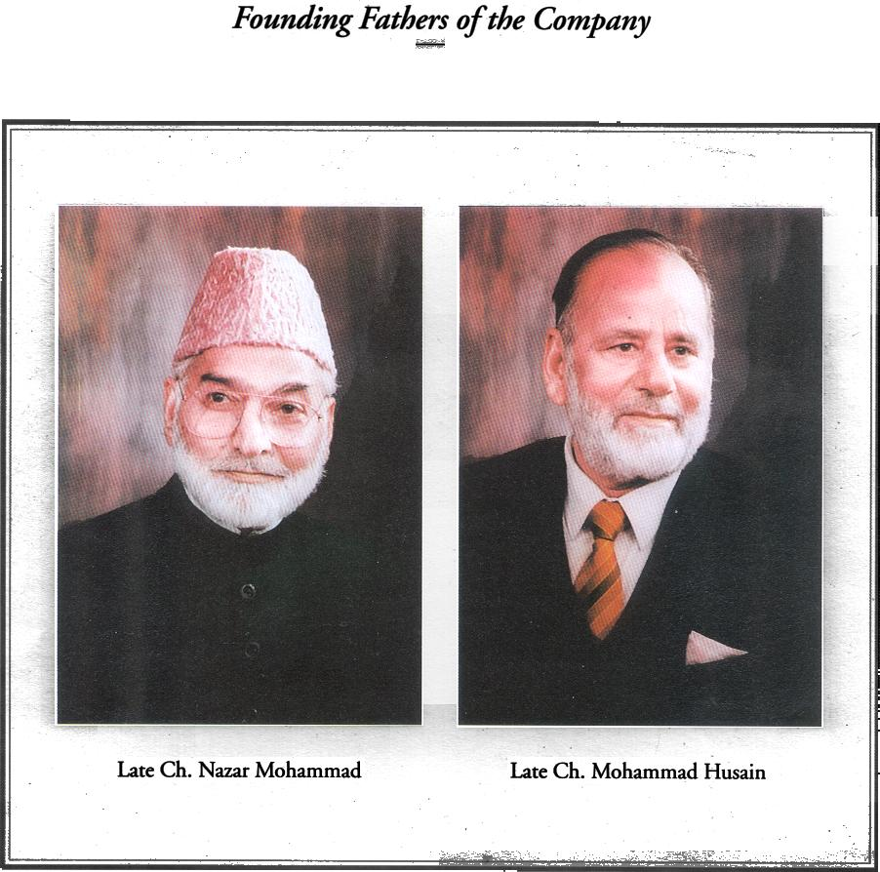

COMPNAY’S MISSION

- To satisfy the customer by provides quality and reasonable price footwear other products through out the country.
- To satisfy its employees through good management.

COMPANY’S OBJECTIVE

- The product should meet the customer expectations.
- The basic concern is to satisfy customers.
- To provide good job opportunities and satisfactions to the people.
- To respect our competitors.
- The employees are as important as external customers.
- Teamwork and cooperation are more important than individual action.
- Never be satisfied with the level of quality always strive for continues improvement
- No compromise on quality

COMPANY INFORMATION

Board Of Directors Ch. Ahmed Saeed (Chairman)
Mr. Shahid Hussain (Chief Executive)

Mr. M. Ijaz Butt
Mr. Mohammad Akram
Mr. Zahjid Hussain
Mr. Shahid H. Kardar
Mr. Abdul Latif Uqaili (Rep. Of ICP)
Mr. Fiyaz Ahmed Longi (Rep. Of NIT)
Ms. Shehnila Parekh (Rep. Of NIT)

Company Secretary Mr. Sultan Anwar

Bankers Habib Bank Limited
Standard Chartered Grindlays Bank Ltd.
Standard Chartered Bank
United Bank Limited
Muslim Commercial Bank Limited
Emirates Bank International
Faysal Bank Limited
Mashreq Bank
Societe General, The French and International Bank
National Bank of Pakistan

Auditors S. M. Masood And Company
Chartered Accountants

Registered Office Servis House, 2-Main Gulberg, Lahore-54662
Phone no. 5751990-96
Fax No. 5710593, 5712109, 5711827

Share Registrar Soft Link (Private) Limited
Wings Arcade, 1-k (Commercial) Model Town,
Lahore.

Factories G. T. Road, Gujrat.
Muridke-Sheikhupura Road, Muridke

SERVICE GROUPOF INDUSTRIES

Service groups consist of thirteen industries of various kinds and sizes. Six industries are public limited and seven are private limited. These associated companies are situated in various parts of the country having district activities from each other. These companies may or may not have a direct link with their parent company. The detail of public limited and private limited companies is below.

PUBLIC LIMITED COMPANIES:
- Service Industries Limited.
- Service Sales Corporation Limited.
- Dar-e-Salam Textile Mills Limited.
- Halal Tanneries Limited.
- Vogue Limited.
- Agro international limited.

PRIVATE LIMITED COMPANIES:
- Prestige industries Pvt. Limited.
- Exhibits Pvt. Limited.
- Millat high traders Pvt. Limited.
- Shahid Arif Investment Pvt. Limited.
- Service Pakistan Pvt. Limited.
- Adcon Pvt. Limited.
- Nazar Saeed Developer Pvt. Limited.

SERVICE INDUSTRIES LIMITED

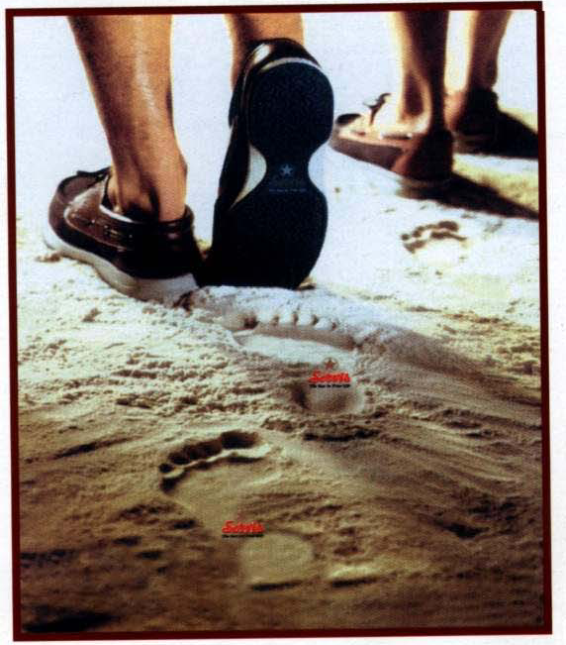

GUJRAT is an industrial area, which consists of fan industry, ceramics, other small manufacturing factories and SIL GUJRAT.
I had the opportunity to see the role this company is playing in the economy of Pakistan. My internship was aimed at understanding the management and administration of such a successful and highly reputed industry. It helped me in observing the theoretical part of my Post Graduation into practical shape.

SIL Gujrat was established in 1964 by the pioneers due to the home district. The SIL Gujrat consists of five manufacturing units. The wide range of products manufactured includes Leather & Canvas footwear, Textile, Cycle, Motorcycle & small car tyres/tubes, Respiratory Anti Gas masks, Medical syringes and water purifiers.

Each factory comprises of about five hundred to thousand workers depending upon the workloads. The factory’s peak season starts from September to April. During this period, the factory hires extra workers and lays them off after the period once the production is normal. SIL’s Head Office is located at Lahore. The entire organizational authority is represented with the help of Organizational Chart, which is headed by a RESIDENT DIRECTOR.
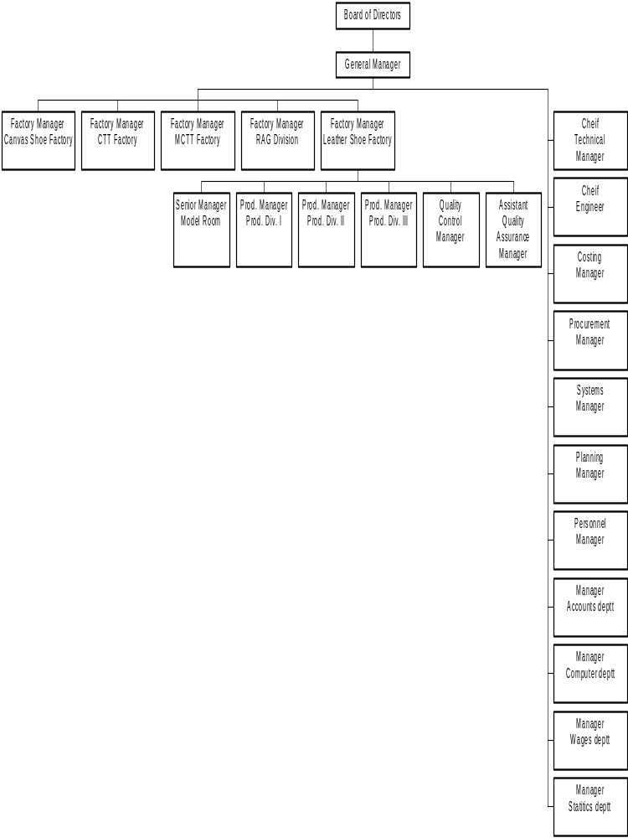Organizational Chart of SIL Gujrat

Presently, there are five factories operating at SIL Gujrat employing approx. 5000 persons. These are: -

- Leather shoe Factory.
- Canvas shoe Factory.
- Cycle Tyre & Tube Factory.
- Motorcycle Tyre & Tube Factory.
- RAG Division.

- LEATHER SHOES FACTORY

Manager Ayaz Akram

Experience 17 years

Manpower 1500 workers

This factory is the basic of the most important unit of SIL. The Leather Shoe Factory comprises of about 1500 employees. Its production capacity per day is about 9,500 pairs of export and domestic articles. It is worth mentioning here that almost 60-65 % of the local production is meant for export and hence, our slogan “The Largest Exporters of Footwear”. The export percentage in itself is a measure of our quality standard and well-controlled rejection limits of 2.5-3.0 % and 95 % of our total exports are meant for European customers. It has been divided into 2 divisions i.e. Production Division I & Production Division II.

ISO Certification
LSF is the first unit, which has got ISO 9002 Certificate. Its credit goes to the whole team of LSF.
Planning Process
Each factory at SIL has its own planing section, which plays a very important role in the working of the factory. Production schedule prepare by the planing section is called production plan formula or plan. Nothing in the factories could be produced without the production plan.

The process starts: -
One a work order is received by the pig sec from SSC Lahore.
The work order is studied and calculated that when the delivery will be possible info to SSC Lahore.
If the customer agrees, SSC Lahore informs the pig section of the concerned factory at Gujrat.
Planing section allots a plan no to the work order.
A plan no is allotted from CALENDAR to a work order according to the delivery date. It makes easy to con the production and to make the deliveries in time.
A plan is made at least a week before its starting date.
The planning office prepares an estimate for the Raw Material, which is to be consumed to manufacture the order. This estimate is sent to the concerned stores that the factory needs this Raw Material on such date.
The production plan is handed over to the factory a day before the plan has to start.

PRODUCTION DIV I

Production Manager Nasir Ali Khan
Experience 36 Years

Salient Products
Export
Opankan shoes (Ladies)
California Shoes (Ladies)

Local
Schoolmate shoes (Boys & Girls)
Champ Joggers (Boys)
Top siders (Men’s moccasion shoes)
Air VENI Joggers (For Men)
Cheeta Squash shoes (For Men)
Luxury Sandal (For Men)
Soft Step (For Male And Females)

PRODUCTION DIVISION II

Manager Asif Majid
Experience 15 Years

Manpower 250 Persons

Article: -
a. Duke - Men Shoes
b. Don Carlos - Men Shoes
c. F.T - Men Shoes
d. Atlanta - Men Shoes
e. Bostan - Ladies
f. Cheeta - Jogger for Men

Shifts 2(Day and Night)
a. 1xForeman for cutting - 50 persons
b. 4xForemen for closing - 55 persons

Production Period
March to April and August to September

Local Production Period
3 months in advance - order from SSC Peak period is Oct to Mar.

Working Days
5 days i.e., Monday to Friday
Working Hours
0730 hrs to 0530 hrs (incl. 2 hrs lunch/break)
Over Time
No overtime is allowed in daily working hours except office days. Either overtime is paid or leave in lieu is granted.

Aims
Factory targets are achieved 95% to 100%.
Shoe making has long op and every step has to be completed one after other.
Over all rejection should be within 3% starting from cutting to packing.
Std sizes are prepared basing on costing sheets.
Uppers are produced for Poly Urethanes (PU) department.
If capacity is avail, the production of prod I can also be done in this plant.

- CANVAS SHOES FACTORY

Manager Inam Akhtar

Experience 25 years

Manpower 900 workers

The Canvas Shoe Factory is one of the largest of its kind in the country. It is the biggest exporter of canvas shoes. The major clientele comprises of famous brands of U. K., Germany, Denmark, Holland, France and Italy. Locally the shoes are marketed through our sister concern Service Sales Corporation. Average work force of Canvas Shoe Factory is about 900 workers; this varies from season to season and goes up to 1000. The installed capacity of Canvas Shoe Factory is 7,920,000 pairs per annum. The factory follows the motto “customer satisfaction at priority” and that is the reason it is thriving for the last 38 years.

Orders are received from the following sources: -
Services sales cooperation (SSC)
Export department of Head Office Lahore.

Production Starts
Manipulation is the process in which cloth is pasted with living and rubber layers are put in between cloth.
Cutting
Cutters are used as per model/design of the shoes.
Defective sheets due to textile texture or cutting are separated.
Department no plan no and size are stamped on each cut sheet.
Closing/Stitching
Stitching is done as per design, single or double.
Quality Control
Quality checkers check quality at each stage.
Assembly
Counts the total units produced
Books the plan for wages of the workers.
Making/Confection
Each plan is splitted into 3 rounds depending on the availability of the lasts.
Cementing and lasting
Pressing and dipping
Quality Checking.
Quality is checked at this stage also.
Vulcanizing
The shoes are put on last trolleys i.e. 50 each.
4-5 trolleys are pushed in the vulcanize
These shoes are vulcanized on 135C’ for 1 hour
Then the trolleys are pulled out and kept in front of cool air for 10-15 min and the shoes are de-lasted.
Quality Control Department
Final quality check is done here.
The quality check failure pairs are graded as ‘B’ pairs.
Codes and stickers are used for export
Price printing is done for local as per instruction of SSC.
Packing
For Export
Assortment packing is done depending on various sizes of the shoes.

Solid packing is called only one size export
After packing, it is dispatched to the GODOWNS, which arranges its shipment from Karachi.
For Local
SSC instructions are followed which is normally solid packing.
After packing, retail orders are sent in the RETAIL GODOWN of the factory.
The wholesale orders are sent to the WHOLE SALE DEPOTS.
3. C.T.T FACTORY
Manager Khawaja Saeed Akhtar

Experience 20 years

Asst. Manager Qasim Wajahat
Experience 14 years

Manpower 900

Production capacity
The production capacity of bicycle tyre & tube is 14000 and 19000 in number with rejection 3% and 1% respectively. C T&T factory of SIL holds about 55% of the Market share.
Tyre Division has been supplying tyres & tubes to all major original equipment manufacturers (OEM) with high share like 100% to Sohrab Bicycle Manufacturing Company, Lahore.
The orders are received from distributors for any particular brand or Increase/Decrease in some sizes. S.I.L have appointed 5 Distributors in the country.
H.K. Rehman and company Lahore
Mushtaq Rafique and company Faisalabad
Wajid Ali Agencies Rawalpindi
Imperial Traders Lahore
Imperial traders Sukkar

Production Planning
Production orders are received through the Marketing manager from the distributors and passed to factory manager.
Factory Manager does himself keeping in view the production capacity and planning production.
Factory Manger also advises procurement Manager for Raw Material.
Large Brands: -
Long life Yellow
Long life loader
Cheeta
Cheeta plus
Supreme
BMX Range
Power

4. MOTORCYCLE TYRES & TUBES FACTORY

Manager: G.A Cheema
Experience: 9 Years

Manpower: Tube Division: 115
Tyre Division: 160

Tube Division.

Production Manager: Nadim Bhatti.
Experience: 3 years

Raw Material Imported: Nozzle and tube compound is imported from
Korea, Taiwan & China.

It holds market share of 45% in Motorcycle Tyre and tube. Production capacity of Motorcycle, Scooter, Trolley, Rickshaw and ULT Tyre & tube is 4000 and 11000 in numbers with rejection rate of 1.5% and 0.5 % respectively. Rejection material wastage and claim percentages are itself a measure of quality standard.

TYRE DIVISION

PRODUCTION MANAGER: Imtiaz Ahmed Butt.
Experience: 7 Years

Tyre Division has been supplying tyres & tubes to all major original equipment manufacturers (OEM) with high share like 70% to Atlas Honda Limited (AHL), 50% to Islamabad Automotive Company Limited (IACL).

High quality importance is given to this department.
Internal Quality Checker checks finished tyres. And then graded the tyres as A, B.
- High quality tyres are labeled as grade A.
- Little bit defective tyres are labeled as grade B.
- More defected tyres are return to production department.

5. RAG DIVISION

Manager: Mr. Altaf Hussain
Experience: 20 years (6 months in Servis)

Manpower: 120 workers

Products: Army related things i.e. Gas Masks, Cover of hand garnets, IV tubes and Chain of tanks.

Sales: RS: 5254004 (In July)

Customers:
Pakistan Ordinance Factory (P.O.F) Wah Kantt, Wah Kantt purchase its most of its production. Only Gas masks are sold to the other parties. The Pak Army supervises rag Division.
ISO 9001:
Rag Division is certified from the ISO 9001 in the 1998. This certificate proves that this factory is very well organized and has automatic technology.
Highly Sophisticated Laboratory:
The factory has highly sophisticated test laboratory, maintain by qualified and trained persons. RAG Division own well-equipped laboratories. It is here that the further products are developed & tested thus ensuring the success of the company.

Personnel Department

Manager: Abdul Salaam
Experience: 32 Years.

Recruitment of Employees:
The applications are recommended by the local councilors, public relation, officers and political heads of Pakistan Peoples Party.
The workers are preferred from NA-81; Ch Ahmed Mukhtar Vs Ch. Shujaat Hussain (PML-Q)
National Identity Card is must as it is used during elections.
Minimum educational standard was middle (Now metric is compulsory).
Factory manager concerned interviews the candidates and gives suitability.
The applications are put up to General Manager.
General Manager after consultation with Resident Director makes final selection.
Trial Card is prepared and issued to the individual for the concerned factory as a Probationer.
After 8 months trials, Head of Department gives satisfactory or unsatisfactory remarks about the performance of the individual.
On satisfactory remarks only, the worker is CONFIRMED as a regular employee.

- Semi/Skilled Only.
Have to pass the requisite technical test for selection.

- Recruitment of Supervisors/Foreman/Clerk/Storekeeper.
As and when the vacancies are created, the applications are invited through Press or personal contacts.
The applications are vetted and merit list is prepared depending on the education.
The candidates are tested as per their trade/category.
The documents are forwarded to the Head of Department/Factory Manager. They interview the candidates and write their suitability report.
The documents are put up before General Manager who gets formal approval from Resident Director to decide about their Pays & Allowances.
The formal appointment letter is issued indicating the wages and Trial Period i.e. 3 months/6 months.
After the PROBATIONARY PERIOD, Performance Report is written. If it is satisfactory, the Probationer is confirmed.

- Training Executives.
The following pre-requisites are advertised through press on creation of vacancies for the: -
Mechanical/Chemical Engineers.
Trainee Manager
(Costing/Accounts/Production/Personnel/Procurement/ Computer System).
Security Officer.
Education.
BA/BSC or MA/MSC or equivalent.
Age.
25 to 30 Years.
The applications are vetted and merit list is prepared.
The candidates are called for tests/interviews through letters.
The selection board takes test of the candidates. The board always comprises of any one of the Technical Representatives i.e. Chief Engineer, Chief Technical Manager and Executive of Research & Development (R&D).
The results are submitted to General Manager.
The G. M discusses the results with RD and finalizes the selection.
The selected trainee executive is PROBATIONER for 3-6 months.
During probationary period, pay is RS 5000/- per month.
After probationary period, Head of the Department/Factory Manager initiates the “PERFORMANCE REPORT”.
The suitable executives are CONFIRMED as Assistant Managers.
The G.M and RD decide the final Pay and Allowances.

PROMOTION:
The promotion policy is as following: -

- Skilled Worker (Electricians, Mechanical & Fitters)
Skilled workers are promoted if they fulfill these conditions: -
Education: Metric
Experience: 5 to 6 years
- Promoted as foreman-II
5 to 10 year experience as a good worker.

- Promoted as foreman 1.
4 to 5 years experiences as Foreman-II
And 3 good ACRs.

- Promoted as Group Foreman.
Once he attains higher education, can be promoted as Group Foreman.
He is given 2 Extra Increments.

- Office Assistants.
All lower staff; Planning Assistants, Gate-Assistants, Assistants Security Officer, Costing Assistant, Data Operator Assistant storekeeper etc must meet the following conditions for promotion.
Education - FA or Equivalent Professional Diploma.
Experience - 4 to 5 years.
At least 3 good ACRs
2 Extra Increments will be entitled on promotion.

- Executives.
The executives must also meet the following criteria for promotion into Grade 11 to 12.
Education - Minimum BA/B.Sc. or equivalent.
Science Graduates shall be entitled for RS 200 extra.
Chemical, Electrical, Mechanical, Civil Engineer, MBA, M Com, and LLB etc shall be entitled for RS 1000/- extra.
8-10 experience and 3 good ACRs are must for promotion as manager into grade C-13 & C-14.
It is the highest ceiling in these ranks. After this, it is the Management’s discretion to pick the most suitable candidates for: -
Factory Manager
Chief Technical Manager
General Manager.

Wages and Fringe Benefits:
SIL is one of the few factories that are paying a fairly handsome amount of daily wages to its workers. The workers are satisfied with the wages, as most of the workers are resident of Gujrat & surroundings
- Workers.
The workers, who are employed on daily wages, get their payment on the piece rate system. The costing department works out the detail of the payment in such a manner that every worker gets more than the laid down in labour laws. The profit is distributed among the workers too.
- Staff.
The wages/pay is fixed at the time of appointment Depending on the performance, annual increments are given.

The following allowances are entitled: -

1. Allowance Amount Max Limit
(a) Punjab Govt. Special Alce 1. Rs 150/- Rs. 1500/-
(b)Punjab Govt. Special Alce 2. Rs 100/- Rs. 3000/-
(c)Punjab Govt. Special Alce 3. Rs 200/- All employee
(d) COLA - 1 Rs 100/- Rs 4165
(e) COLA - 2 Rs 50/ Rs 4215/-
(f) COLA - 3 Rs 300/- Rs 4065/-
(g) SIL Special Allowance Rs 100/- All Workers
(h) House Rent ` Rs 100/- “ “
(j) Regulatory Allowance Rs 60/- (for regular worker
and staff only)
(k) House rent of executives 30% of the basic pay.

2. Group Insurance.
All the workers/staff are insured. The amount is based on BASIC + COLA+H Rent+Spl alce
Wages Sum Assured Monthly Premium
Rs 0001-1500 Rs 100,000 Rs 10.25
Rs 1501-2000 Rs 120,000 Rs 12.30
Rs 2000-3000 Rs 150,000 Rs 15.38
Rs 3000-4000 Rs 200,000 Rs 20.50
Rs 4001-5000 Rs 250,000 Rs25.63
Rs 5001-6000 Rs 300,00o Rs 30.75
Rs 6001 -7000 Rs 350,000 Rs 35.88
Rs 7001-8000 Rs 400,000 Rs 41.00
Above 8000 Rs 600,000 Rs 61.00

- Executives.
The executives have been graded into grades C-11 to C-14.

C-11 to C-12
45% house rent
Motor Cycle 70 CC
Petrol 8 Gallons per months
Telephone (Residence Rs 300-600)
Medical Allowance. 10% of Basic Pay.

C-13 to C-14
50% house rent
Car 800 CC
40 to 60 Liters petrol per months
Entertainment Allowance 10% of Basic pay.
Medical Allowance 10% of Basis Pay
Telephone (Residence) Rs 900/-

LEAVE:

The leave policy of SIL is as under: -
    - Un-confirmed Workers
Are not entitled any leave. They can avail leave without pay for the said period.
    - Confirmed Workers/Staff.
They are entitled
Casual Leave - 10 Days
Annual Leave (Executive) - 15 Days
Annual Leave (Non Executive) - 14 Days

Sick Leave (Under Social Security Rules): -
It depends on the Disease/Sickness & is recommended by an MBBS Doctor. 75% payment is made to the individual by the Social Security on the production of B-2 FARMS.

- Head of the Department/Factory Manager recommends Casual/annual leave.
- A Personnel Manager approves of it is filed and attendance Register is filled accordingly.
- Any leave availed more than authorization is to be without pay.

LAY OFF:
Whenever any factory is not in production, due to any reason, the work force/workers are informed to go on LAY OFF. For next 30 days. They are paid HALF of the months pay by the factory.
On the restart of operation, they are called back.

DISCIPLINE/DISCHARGE:
Every worker/staff are bound to abide by the Rules and polices of the factory. Any break of Trust or failure to apply the Rule is liable for legal action against the individual.
The following procedure is followed: -
- A charge Sheet is given to the individual to explain his viewpoint within the specified time.
- If the reply is un-satisfactory, these actions can be taken: -
  - Warning - On mild offence.
  - Given on additional chance conditionally.
  - Dismissed from service immediately.
- If the individual doesn’t reply within the stipulated time, one-sided action is taken.
- An individual may be terminated on the un-satisfactory performance during Probationary Period.
- A resignation can be accepted provided one-month prior notice is given otherwise one-month salary is deducted as a fine.
- A special case resignation is also acceptable. But the individual is re-employed at the same time. In this case, the individual is helped financially by drawing his emoluments + SPFT etc.

STATISTICS
SECTION


Manager Muhammad Ashraf Bhatti
Experience 20 Years

Function:
- To provide data to all government departments, SIL management in connection with prices, production, sales manpower.
- To provide data for taxation purposes.
- To calculate foreign exchange for export.
- To calculate data for imports and local purchase
- To maintain records of assets; Buildings, Machinery, Fittings/fixtures.
- Current Assets, cash and accounts receivable.
- Central excise and sales tax
- Payment of sales tax at 15% for local sales. For following items: -
Footwear, Bicycle Tyre and auto Tyre tubes.
15% sale tax on imports of raw material.
Govt.’s rebate in sales tax is deducted in FINAL RETURN
- Filling of Tax returns by 15th of each month. In case of delay Rs 5,000 fine is to be paid. A delay more than a month would case additional 2% tax along with legal action.
- To calculate depreciation at the rate of: -
Machinery 10%.
Building (Factory) 10%.
Colony (Building) 5%.
Equipment including office equipment10%.
Vehicles and electrical items 20%.

WAGES
SECTION


Manager Muhammad Amin
Experience 26 Years

Aim: - Correct wages it’s correct nab at correct time.

Procedure
Costing dept. of each factory determines/fixes the rates of each process of operation to be performed by each labour depending on the nature of order. The rates are fixed in consultation with factory manager.
One copy of costing sheet is given to the factory concerned and the other to the wages section.
After the start of production, payment is made on fortnightly basis.
Planing dept. verifies the actual production, then the incharge of the concerned depts. , Prepare WAGES SHEETS; indicating no. of present days of each labour, type of operation/process and the no of production units.
The wages section receives these sheets.
The working calculation of wages in done here within the authorized sealing/limits and no extra payment is allowed.
Wages envelopes are prepared according to earned wages for each worker indicating the amount.
Envelopes are handed over to cash disbursement cell for filling the cash.
Cash disbursement cell after putting cash in these envelopes returns it to wages section. Here cash is physically tallied with the envelopes.
Wages sheets along with pay slip for each individual are returned to the factory concerned or dept., duly filled wages.
Each individual signs the PAY SILP and retains it.
Wages section rep visits on Job collects the pay slips and hand over cash to the individual.
For absent/on leave employees, pay slips are collected from the dept. and retained by wages sec. Payment is made on arrival.

Payments to staff on monthly bases
GM, in consultation with R.D fixes the salaries of the permanent employees/staff at the time of appointment.
Increase in pay/allowances or the top management depending on the ability and efficiency/ACR of the individual also decides increments.
Allowances are paid as per the govt. notification.
Payment bills are prep and signed by the staff/employees.
All the permanent staff/employees open their accounts in the Bank and payment is made through banks.

Misc. Duties
Social security contributions are prepared on monthly basis at the rate of 7% per individual.
Wages section prepares claims for sickness, injuries, accidents, and death.
Wages section prepares the pension claims of those employees who attain the age of 60 years and after death the claims of widows.
Income tax deduction of employees.
Wages section works out/calculate the income tax of the employees and deposits in the govt. treasury.
Wages section also works out WEALTH TAX of those employees who are affected by the laws.

EOBI
Wages section prepares monthly contributions at the rat of 5% per individual under the registration of employees with EOBI.

SPFT Fund
The employees deposit minimum 7.5% contribution; the SIL contributes the equal amount. Each year 30% profit is paid on both contributions in the SPFT. The employee gets this fund at the retirement/release.
Loans for the employees can be sanctioned out of SPFT but not more than 50% in extreme cases only.

COMPUTER SECTION


System Manager Muhammad Imtiaz

Experience 1o years

Salient features:
SIL Gujrat has recently been computerized in 1998 is still in the process of computerization for the left over depts.

Hardware:
It has 2 SERVERS: Main database server and Internet server.
It has 50-work station and 10-12 is still in the process of installation.
It has 40 printers.
It has UPS-600 and its STD back up time is 15 min.

The following categories have been computerized: -

- Costing management system.
- Pay roll management system
- Personnel management system (ACRs)
- Accounts management system
- Services provident funds trust (SPFT).

Inventory Management System:
The major achievement is the computerization of inventory. Inventory items costing millions of rupees needed an efficient inventory control management system. So that inventory level could be controlled without affecting the production.
Inventory at SIL Gujrat is of five types: -

- Raw material items
- Finished goods
- Material process
- Raw material borrowed/purchased by some outside coucera.
- Spare parts and technical stores

All types of these inventory items are located in different stores, which are, managed by the storekeepers. The storekeeper provides the data to computer section

Inputs Or The Documents Used By The Computer Section In Inventory Control Management

- Challan Notes
- Stores receiving reports.
- Indent notes
- Bin cards
- Issue notes
- Internal transfer notes
- Debit notes
- Gate passes

- Challan Notes.
Challans are the documents, which confirm that the receiving room clerk receives the supply.

- Stores Receiving Report.
It prepares when the supply is received and taken on charge by the storekeeper.

- Indent Note
It prepares by the asset cost accountants of the factory to make request for issue of raw material from the stores.

- Bin Cards.
The storekeepers to show the transactions of ‘receipts’ ‘issue’ and the current ‘Balance’ of inventory prepare bin cards
.
- Issue Note.
It prepared by the storekeeper in response of indent note which shoes the qty of R/M issued to the factory or any other concern.

- Internal Transfer Note.
Storekeeper prepares internal transfer note when a quantity of R/M is transferred from one store to another store. It keeps the status of each store - house up to date.

- Debit Notes.
Debit notes are prepared when: -
A sale of R/M is made to an outside party.
Some one is allowed to lend R/M from stores.
A return of R/M is made from an outside party or any other concern of SIL.
It is prepared to keep the records of R/M received or issued up to date.

- Gate Pass
Any store or article is permitted to be taken out of factory on the authority of Gate pass.

ACCOUNTS SECTION

Manager - Mirza Mushtaq Baig

Experience - 26 Years

Silent Features:
- British style of accounts is being followed in SIL.
- It is based on double entry system.
- All procedure to maintain the accounts is now computerized.

The following duties/tasks are performed by account dept.: -

- Voucher preparation.
- Voucher posting.
- Preparation of statements.
- Cash disbursement
- Preparation of monthly trial balance
- Month end adjustments
- Cash flow projection on monthly basis.
- Financial changes/payments of loans/rents by Head office Lahore.
- All purchases are done through crass check/draft.
- Day to day expenses up to Rs: 5000/- is met through cash and above
Rs 5000/- is met through checks.

Sources of Receipts:
The following are the sources of receipt in SIL Gujrat: -

Recovery from C.T.T & M.C.T.T.
Recovery from sales of shoes / TT through fair price shop.
Recovery from SSC on account of shoes sold on direct basis.
Sales proceeds of left over Raw material.

Payments:
The payments are made in the following heads for SIL GUJRAT.
- Wages to workers.
- Salaries to staff.
- Perigee benefits.
- Utility expenses are made on reimbursement basis.
- Govt. Dues.
The following payments are made to Govt.: -
- Custom Dues
- Sales tax.
- Electricity, Sui gas and telephone expenses.
- Employee’s old age benefits subscriptions 5% per individual.
- Employee’s social security fund subscription 7% per individual.

Payments to Suppliers:
- The suppliers are paid on credit/cash basis
- Venders are paid on cash basis.
- Foreign suppliers are paid up to a limited level.

Misc. Tasks:

The account section also performs the following tasks: -

- Comparison of cash flow, Budgeted Vs actual
- Capital investment on factory wise basis report.
- Fixed assets schedule report.
- Comparison over heads report budgeted Vs actual
- Fixed overheads
- Variable overheads
- Fringe Benefits.
- Preparation of production statement.
- Current year Vs last year.
- Month wise production and its sales value.
- Wages/salaries statement.
- Current year Vs last year basing on No. Of employees and
their wages/salaries bills
- Preparation of report on working Capital.
- Budgeted Vs actual.
- Receivable / outstanding
- Raw material including stocks on way.
- Finished goods stocks
- Advances / prepayments
- Cash / Bank balance on hand.

LABOUR UNION 

- SIL is an industry which is labour-friendly & has its union, “SERVICE- WORKERS UNION (REGD), GUJRAT. The union was established in 1970.
- SIL also has a “SERVIS EMPLOYEES UNION (REGD)” which plays a role of an opposition.

Process of Election:
Workers elect the office-bearers of the union i.e., President of General Security for a period of 2 years.
President of the General Security nominate the remaining 4 persons of the Union.
These 6 nominate another 6 persons as a Governing Body.
If the opposition; SERVIS Employees Union demands the fresh election, only them it can be held otherwise the same body can continue for the next 2 years.
Vote-of-No Confidence motion can be moved in the Director’s office for fresh election.

The Office-Bearers for the 2001-2002 are: -
a. President: Mr. Ashiq Hussain
b. Vice President: Mr. Fazal Ahmed
c. General Secretary: Farzand Shah
d. Joint Secretary: Muhammad Yousaf
e. Propaganda Secretary: Muhammad Afzal
f. Treasures: Muhammad Asghar
Membership
Membership form is filled to make members.
Membership fee is Rs 1 per month
Total membership
(In the start of 2001)- 2710
Joined during 2001 - 177
Left during 2001 - 844
At the end of 2001 - 2039
Funds
In the past, the factory management has banned the collection of funds from the workers. Lately it has been allowed only Rs 1 per from each worker.
It is a Joint Account of only to be operated by the president/General Secretary/Treasure.
Any member can be nominated to AUDIT the funds before 31st of March each year.
The Funds State for Dec 31, 2001 is: -
(1) Total Income: Rs 24332/-
(2) Total Expenditure: Rs 23000/-
(3) Balance : Rs 1332/-
Functions:
- The problems of the workers are reported to the Union Office through formal/ informal sources.
- The Union discuses the case with the PERSONAL Manager and the problem is resolved at local level.
- If the problems are not solved then the union is allowed to visit the RD The R.D has his open door policy for workers from 1500 to 1700 hrs daily.
- If the resident director fails to satisfy the worker, the Union gives notice to CHAIRMAN, at head office Lahore.
- The Chairman calls the meeting of the Management and the union and decides the issue.
- If there is no outcome of this meeting, the union takes its legal actions.
- A notice is served to the provincial labour Minister, province labor secretary, DC, SSP, Joint Director labour, Gujranwala and head office of the Industry for immediate resolution of the problem.
15 days prior notice is served for any action.
4 days notice is given for any action.
2 days final dead line is given.
- Then Strike.
- The alternate option is though COURT.
- The union moves it case though court. The legal advisors on the panel are:-
Ch Faiz Ahmed Advocate, Gujrat.
Khwaja Ahsan Advocate, Gujrat.
Mr. Naeem Bokhari Advocate Lahore High Court.
- The union pays for the services of the lawyers.
- If the union wins, the factory has to pay the compensation to the worker/union.
- If union loses no compensation is payable.
- There is no COURT CASE/strike since last 30 years in this factory.

UNION’S EFFORT FOR WORKERS (During 2002):
- Marriage grants have been given to 32 Workers for the marriages of their daughters/sisters from social security fund amounting to Rs 5,20000.
- 306 Bicycles and 50 sewing machines have been distributed in workers through balloting from labor dept. of Punjab Govt.
- Punjab Govt. has granted education stipends worth Rs 1,91,505/- for approx. 600 children of workers.
- Bonus /Profit is distributed by the company every year on the notice of the union.
- Recently 5% pay has been increased on the behalf of the union.
- Union forwards the requests for grant of aid on the death of parents, children wife, brother or sisters of the deserving workers.
- In case of emergency, max up to Rs 10,000 are paid to the workers on their treatment from any other hospital through union.
- 500 deserving widows and disabled are being given stipends by the factory.
- Deserving workers are given clothes and shoes free of cost.
- Disabled persons all over the country are given shoes, free of cost, including EDHI Foundation.
- In case of floods, the deserving workers will take financial assistance.
- Financial assistance is given on The Eids by efforts of union.
- All the workers are given 30% discount on purchase of shoes.

Internal Audit Program



The SIL has its own internal audit for the evaluation of quality activities. This procedure is applicable to whole factory and it’s allied departments in SIL (G).
- General Manager prepares a comprehensive annual audit schedule, which covers all aspects of quality system and audit should be conducted at least twice a year.
- General Manager assigns auditors for the audit and informed through an office circular.
- Auditor should be independent.

Planning Quality Audits:
- Auditor gets the relevant document
- Auditors prepare an audit plan
- Copies of audit plan are submitted to the General Manager and the departmental head before the audit.

Preparing Audit Checklist:
Auditors prepare an audit checklist, which acts as a guide for him before and after the audit. This list consists of leading questions, which ensures that no area of the audit is missing. This list may be submitted to the General Manager after the audit for record purpose.

Conducting the Audit and Follow Up Audits:
- The auditor will conduct the audit on the already agreed date between the department and him. This date is mentioned on the audit plan, which is submitted to the General Manager. Is case the audit is not conducted on the prescribed date and new date is mutually decided and auditee is informed in writing.
- If the auditee has any problem about the date of the audit plan he shall inform the auditor in writing and new date for the audit is decided mutually.
- The auditor explains the methodology of the audit in the opening meeting.
- The auditor uses the checklist as his reference document and note down all his observations and this is also used for the identification of non-conformity observed. Reference of the checklist is provided on the Internal Audit Non-Conformity Form.
- Auditor fills an Internal Audit Non-Conformity Form and then discusses it with the departmental head and Corrective Action is proposed and completion date is also decided. Two copies of Internal Audit Non-Conformity Form are prepared, one for departmental head and other is for auditor.
- Departmental head and the auditor check the effectiveness of the proposed corrective actions during the follow up audit. The follow up audit is conducted on the date mutually agreed during the actual audit.
- An internal audit summary will be generated after every audit by the auditor and given to the auditee for his remarks about the audit. The auditee gives his comments on the internal audit summary. This internal audit summary along with internal non-conformity form is submitted to the General Manager.
- After internal quality audit the General Manager reviews the effectiveness of the audit by using the audit results.

Internal Audit Records:
All records related to the audit i.e., annual audit schedule, audit checklists, internal audit non-conformity form, internal audit summary and form for review of IQA results are kept by the General Manager.

FINANCIAL STATEMENT ANANLYSIS



Financial statement analysis provided some insights, but also has raised a number of questions, which only a more specific analysis can answer. The measurement of business performance is more complex and difficult, since it must deal with the effectiveness, which capital is employed, the efficiency and profitability of operations and the value and safety of various claims against the business. In these points you will again recognize the results should be related to the basic decisions on investment, operations and financing.
Essence Of Analysis
Many persons and groups normally take an interest in the success or failure of a business. The most important are owners/ investors, managers, leaders, labor organizations, governmental agencies and social groups. Depending on their objectives, they will view business results selectively as to financial measures, and beyond this will often include intangible values. Since viewpoints and objectives cannot be separated, we shall structure the materials in relation to the major interested parties and those measures most meaningful to them.
MANAGEMENT:
Closest to the business from a day-to-day standpoint, but also responsible from long range plans, is the management of the operation-whether composed of professional managers or owners/managers. Managers are responsible for efficiency development of capital and other resources in the process.
OWNERS:
The owners of the business in term are interested in the current and long term profitability of their equity investment, reflected in growing earnings and dividends and in the rise of the economic value of their stake relative to the risk encountered.
CREDITORS &LENDERS:
At the same time, the providers of other people’s money, creditors and lenders of short and long term nature, are oriented toward steady interest payment, the ability of the business to repay the principal and reasonable specific or residual asset values as a margin of protection for risk.
Profit & Loss Account
Service Industries Limited

STATISTICS FOR 2001 In Thousand

Sales - 2324397
Cost of Sales - 1981101
Gross Profit - 343296
Operating Expenses - 205888
Financial Charges - 82370
Profit before Income tax - 89269
Income Tax - 21919
Profit after Income Tax - 67710
Cash Dividend - 36086
Transfer to General Reserve - 31000
Unappropriated Profit Carried Forward - 812
Share holders Equity - 482955
Shares Issued (No) - 120288
Earning per share after Income Tax - 5.63
COMPANY’S FINANCIAL POSITION AT A GLANCE

BALANCE SHEET

As on December 31,2001.
RS. 000's
Share Capital & Reserves

Share Capital 120288
General Reserves 361855

Unappropriated Profit 812
482955

Liabilities Against Assets

Subject to Finance Lease 46525

Deffered Liabilities
Staff Gratuity 21869
Deffered Taxation 15329
37198

Long Term Advances & Deposits 90

Current Liabilities

Current Portion of Liabilities against Assets 34,565
Short Term Running Finance from Banks 609,641
Creditors,AccruedExpenses&OtherLiabilities 349,214
Dividends 24,699
1,018,119

1,602,835

Tangible Fixed Assets
Operating Fixed Assets 229369
Fixed Assets Subject to Finance Lease 65109
Capital Work in Progress 1899
296377
Long Term Investments 5817

Long Term Deposits 11789

Current Assets
Stores, Spares & Loose Tools 9301
Stock in Trade 612687

Trade Debts 584853
Advances, Pre-payments & Receivables 165862
Cash & Bank Balances 1909
1374612
1688595

Various Techniques of Analysis
There are four types of techniques to analyze a company. These are as follows:

- Trend Analysis
- Ratio Analysis
- Graphical Analysis
- SWOT Analysis

- Trend Analysis:
Trend analysis means to see trend of the financial statements of the company. Whether the trend of the company is positive or negative. A financial statement includes the Income Statements & Balance Sheet. The balance sheet summarizes the assets, liabilities, and owner’s equity of a business at a moment in time, usually the end of a year or a quarter. Next, the income statement summarizes the revenues and expenses of the firm over a particular period of time, again usually a year or a quarter. Though the balance sheet represents a snapshot of the firm’s profitability over time. From these two statements, certain derivative statements can be produced, such as a statement of retained earnings, a source and uses of funds statements, and a statements of cash flows.
So the trend analysis of the financial statements (Balance Sheet & Income Statement) show the real position of the company. And by this analysis we can see the strength and weaknesses of a company. And we can take a positive decision of investment in the company.
TREND ANALYSIS OF INCOME STATEMENT
SERVICE INDUSTRIES LIMITED
2000-2001
Particulars | Increase / decrease
Particulars | In rupees (in 000) | In Percentage
Sales  Cost of Sales  Gross Profit  Operating Expenses  Financial Charges  Profit before Income tax  Income Tax  Profit after Income Tax  Cash Dividend  Transfer to General-  Reserve  Unappropriated Profit- Carried Forward  Earning per share | 315752  263639  52113  17701  24507  47486  10919  36567  12028  24000  624  3.04 | 15.71%  15.35%  17.90%  9.40%  42.35%  112.68%  99.26%  117.42%  50%  342.85%  331.92%  117.37%
TREND ANALYSIS OF BALANCE SHEET
SERVICE INDUSTRIES LIMITED
2000-2001
Particulars | Increase / decrease
Particulars | In rupees (000) | In Percentage
Share Capital & Reserve  Issued, subscribed & paid up Capital  Reserves  Unappropriated profit  Liabilities  Liabilities Against Assets  Deferred Liabilities  Staff gratuity  Deferred taxation  Long Term Advances & Deposits  Current Liabilities  Short term borrowing from banks  Current portion of liabilities against F/ L  Creditors, accrued & other liabilities  Dividend payable  Total current liabilities  Total Liabilities & Capital  ASSETS  Tangible Fixed Assets  Operating fixed assets  Fixed assets subject to finance lease  Long Term Investment  Long Term Deposits  Current assets  Stores, spares & loose tools  Stock in trade  Trade debts  Receivables, advances & prepayments  Cash & bank balances  Total current assets  Total Assets | -  31000  624  3282  (3225)  (5171)  -  84350  (5444)  65156  12184  156246  182756  (8316)  20186  (168407)  (2544)  1915  187618  99769  53179  (1742)  340739  182756 | -  9.37%  331.91%  5.60%  (12.84)%  (25.22)%  _  15.51%  (23.70)%  17.43%  48.68%  16.18%  21.14%  (3.50)%  44.93%  (96.66)%  17.75%  25.93%  44.14%  20.57%  47.20%  47.71%  32095%  21.14%

Interpretation:
- Trend analysis of income statement shows that sale of the company is increased by RS: 315752000 in 2001, which is 15.71% increased by the previous year 2000. So the sale of the company seeks to a positive sign. The cost of the goods sold is also increased by the same ratio of sales, which shows the close relation with the sales. The selling & administration expenses are also increased but less then sales percentage witch shows a positive trend and shows the efficiency of management. Due to this effect of efficiency the operating profit of the company is increased by 131.86%, which shows the strength of the company. The net profit of the company is increased in 2001 by 117.42%. In 2000 the company had declared low dividend. But in the year of 2001 the company has declared the dividend of RS: 12028000 that increase the confidence of the shareholders.
- Trend analysis of balance sheet shows overall increase in the amounts. But the reserve of the company is increased by 9.37%. Short-term borrowings from banks and financial institutions are increased RS: 84350000, which show that the management wants to do business with the outsider’s fund. The overall total current liabilities of the company are decreased by 16.18%. On the other hand fixed assets are increased Rs. 20186000, which shows that the company is trying to use the blocked amount of fixed assets, increase the fixed assets of the company. The long-term investment is decreased by (96.66)%, which shows that management wants to invest in his own company, whether to invest in outside the company. Stock & trade debtors are increased in 2001, which shows the efficiency of the company. The overall current assets of the company are increased by RS: 182756000, which show the positive impact of the company.
- The overall trend of the company is positive in 2001, which shows the efficiency of the management.
- Ratio Analysis:
Ratios simply means on number expressed in terms of another. A ratio is a statistical yardstick by mean of which relationship between two or various figures can be compared or measured. Thus Ratio Analysis shows the relationship between accounting data. Ratio can be found out by dividing on number by another number.
Ratio analysis is an important and age old technique of financial analysis. Following are some of the advantages of ratio analysis.
- Simplifies financial statements. It simplifies the comprehension of financial statements. Ratios tell the whole story of changes in the financial condition of the business.
- Facilitates inter-firm comparison. It provides data for inter-firm comparison. Ratios highlight the factors associated with successful and unsuccessful firm. They also reveal strong firms and weak firms, over-valued under-valued firms.
- Helps in planning. It helps in planning and forecasting. Ratios can assist management, in its function of forecasting, planning, co-ordination, control and communications.
- Makes inter-firm comparison possible. Ratio analysis also makes possible comparison of the performance of different divisions of the firm. The ratios are helpful in deciding about their efficiency or otherwise in the past and likely performance in the future.
- Helps in investment decisions. It helps in investment decisions in the case of investors and lending decisions in the case of investors and lending decisions in the case of bankers’ etc.

Types of Ratios:
There are five types of financial ratios that are as follows.

- Profitability Ratios
- Liquidity Ratios
- Solvency Ratios
- Management Ratios
- Coverage Ratios

- Profitability Ratios:
These ratios measure the result of business operations or overall performance and effectiveness of the firm.
Profitability is the main base for liquidity as well as solvency. Creditors, banks, inventors and financial institutions are interested in profitability ratios since they indicate liquidity or capacity of the business to meet interest obligations, regular and improved profits to entrance the long term solvency portion of the business. Owners are interested in profitability for they indicate the growth of and also the rate of return on their investments.
Following are five types of profitability ratios.

- Gross Profit to Sales = Gross Profit / Sales X 100
2000 = 291183 / 2008645 X 100
= 14.50%
2001 = 343296 / 2324397X 100
= 14.77%

Interpretation:
This ratio tells us the gross profit of the firm relative to sales, after we deduct the cost of producing the goods. It is a measure of the efficiency of the firm’s operations, as well as an indication of how products are priced.
The GP ratio of the Service Industries is very good in 2000 & 2001. But in 2001 the ratio is little bit increased. It is good sign.

- Net Profit to Sales = Net Profit / Sales X 100
2000 = 31143 / 2008645X 100
= 1.55%
2001 = 67710 / 2324397 X 100
= 2.91%
Interpretation:
This ratio tells the net profit of the firm relative to sales, after we deduct the cost of producing the goods. It is a measure of the efficiency of the firm’s operations, as well as an indication of how products are priced.
In 2000 the company the company cannot earn more profit. But 2001 the company earns profit 2.91%, which is low.

- Return on Equity = Net Profit / Owner’s equity X 100
2000 = 31143 / 451331 X 100
= 6.90%
2001 = 6710 / 482955 X 100
= 14.02%
Interpretation:
This ratio is more meaningful to the equity shareholders who are interested to know profits earned by the company and those profits which can be made available to pay divided to them.
The company’s position is normal. In 2000 there is low profit for the shareholders, but in 2001 the company have more profit up to 14.02%, which is positive sign.

- Profit on Total Assets = Net Profit / Total Assets X 100
2000 = 31143 / 1505839 X 100
= 2.07%
2001 = 67710 / 1688595 X 100
= 4.01%
Interpretation:
This ratio shows the relationship between the total assets and net profit. Due to the low profit in 2000, the ratio shows the 2.07% profit on the total assets. But the 2001 there are a profit on total assets @ 4.01%, which is low. Higher the ratio will be better for the company.

- Investment Turnover Ratio = Sales / L.term debt + Owner’s equity X 100
2000 = 2008645 / 451421 X 100
= 4.45%
2001 = 2324397 / 483045X 100
= 4.81%
Interpretation:
This ratio shows the relationship between sales & total investment. By this ratio we can analysis that who many capital in the business as a working capital.
The investment turnover ratio of the company is reasonable. That shows the effective management control in the company.

- Liquidity Ratios:
Liquidity ratios are used to measure a firm’s ability to meet short-term obligations. They compare short-term obligations to short-term resources available to meet these obligations. From these ratios, much insight can be obtained into the present cash solvency of the firm and the firm’s ability to remain solvent in the event of adversity. There are two types of liquidity ratios.

- Current Ratio = Current Assets / Current Liabilities
2000 = 1033873 / 965581
= 1.07: 1
2001 = 1374612 / 1121827
= 1.22: 1
Interpretation:
It shows a firm’s ability to cover its current liabilities with its current assets. The current ratio of the Service Company is low according to the standard. It should be 2: 1 for a medium size business. So management should take steps to improve the current ratio.

- Quick Ratio = Quick Assets / Current Liabilities
2000 = 548789 / 965581

= 0.57: 1
2001 = 789759/ 1121827
= 0.70: 1

Interpretation:
It shows a firm’s ability to cover its current liabilities with its quick assets. The current ratio of Service Industries is low according to the standard. It should be 1: 1 for a medium size business. So management should take steps to improve the quick ratio.

- Solvency Ratios:
The term ‘solvency’ refers to the ability of concern to meet its long-term obligation. So solvency ratios are very important for the investors. There are two types of solvency ratios.

- Debt to Equity Ratio = Total debts / Total equity
2000 = 1054508 / 451331
= 2.33: 1
2001 = 1205640 / 482955
= 2.50: 1
Interpretation:
Ratio, that shows the extent to which the firm is financed by debt. Creditors would generally like this ratio to be low. The lower the ratio, the higher the level of the firm’s financing that is being provided by shareholders, and the larger the creditor cushion in the event of shrinking assets values or outright losses.
So company’s ratio is very high. It should be decreased up to 0.80: 1.

- Long-term Liabilities to Fixed Assets Ratio
= L.T. Liabilities / Fixed Assets
2000 = 88927 / 283409
= 0.31: 1
2001 = 83813 / 296377
= 0.28: 1
Interpretation:
This ratio shows the relationship between long-term liabilities and fixed assets. The higher the ratio, the greater the financial risk; the lower this ratio, the lower the financial risk.
The company’s ratio is low, which shows the lower financial risk for the investors.

- Management Efficiency Ratios:
A ratio that measures how effectively the firm is using its assets. In this ratios, we will primarily focus or attention on how effectively the firm is managing two specific asset groups__ receivables and inventories__ and its total assets in general.

- Average Collection Period Ratio = Receivables / Credit Sales X 360
2000 = 485084 / 2008645 X 360
= 87 days
2001 = 584853 / 2324397X 360
= 90 days
Interpretation:
This ratio tells us the average number of days that receivables are outstanding before being collected. Average collection period for the industry is 45 days.
The average collection period of the Service Industries is little bit high. In 2001 the average collection period is only 90 days.

- Inventory Turnover in Days = Inventory / C.G.S. X 360
2000 = 425069 / 1717462X 360
= 89 Days
2001 = 612687 / 1981101 X 360
= 111 Days
Interpretation:
This ratio tells us how many days, on average, before inventory is turned in to accounts receivable through sales. Transforming the industry’s median inventory turnover in days is 111 days.
Our company has a better & strong position in the field of inventory turnover in days.

- Coverage Ratios:
Coverage ratios are designed to relate the financial charges of a firm to its ability to service, or cover, them. Bond rating services make extensive use of these ratios. One of the most traditional of the coverage ratios is the interest coverage ratio that is as follows:

- Interest Coverage Ratio = Profit before I.& Tax / Interest Charges
2000 = 106193 / 57863
= 1.84: 1
2001 = 183481 / 82370
= 2.23: 1
Interpretation:
This ratio serves as one measure of the firm’s ability to meet its interest payments and thus avoid bankruptcy. In general, the higher the ratio, the greater the likelihood that the company could cover its interest payments without difficulty it also sheds some light on the firm’s capacity to take on new debt. With an industry median average of 4.0 times.
The interest coverage ratio is very weak of the Service Industries Ltd. It should be increased up to 4.0 times

GRAPHICAL ANALYSIS

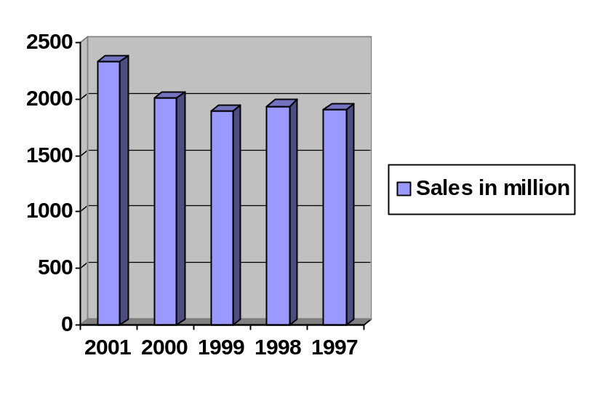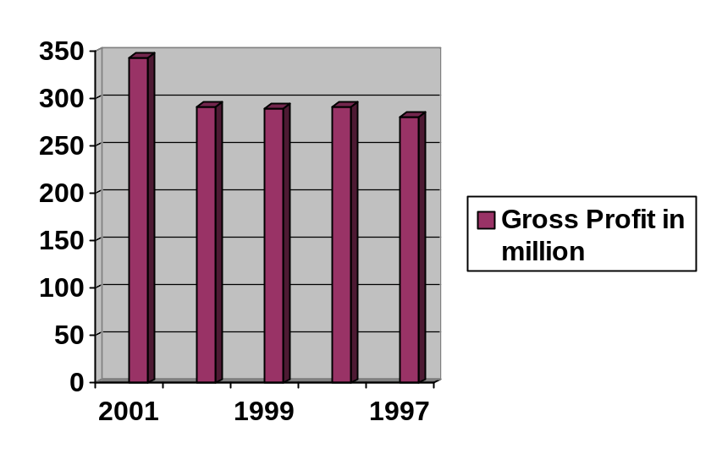

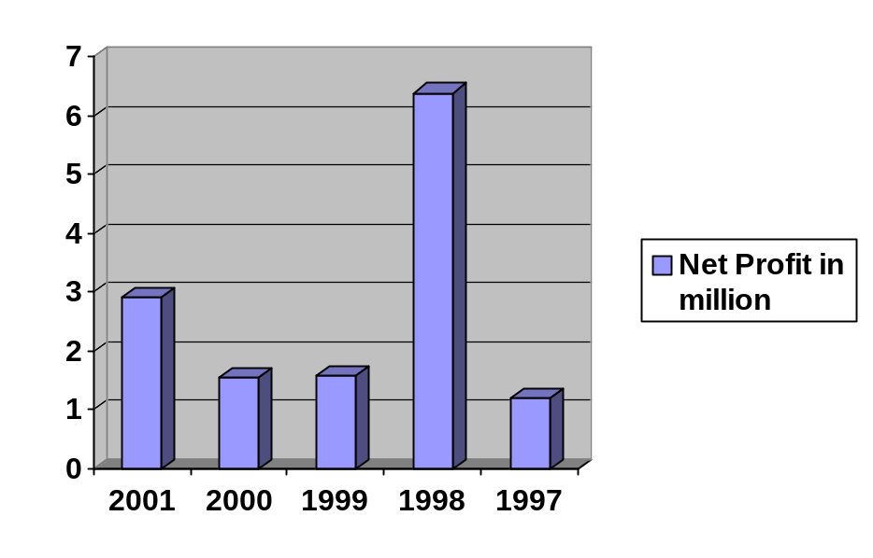

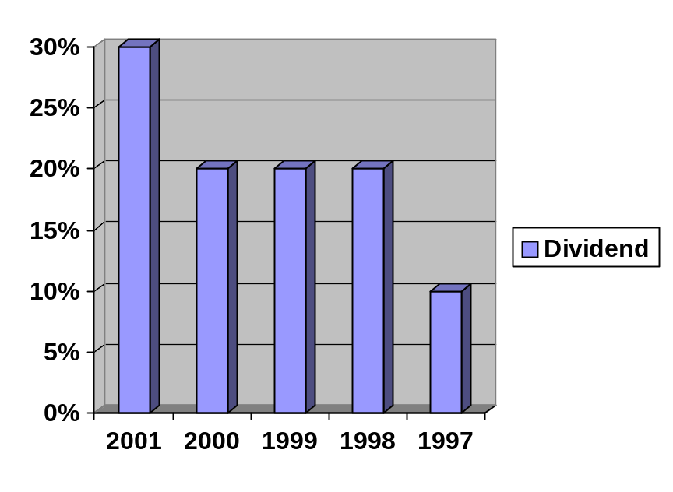

SWOT ANALTYSIS
Strengths:
- Service has its own retail outlets throughout the country.
- It has largest shoes manufacturing company in Pakistan.
- The distribution network of company is fey strong.
- Friendly atmosphere in the organization.
- Less expensive as compared to the imported shoes.
- Quality of the shoes is very good.
- Outlets are available in all markets and bazaars.
- Single competitor (Bata).
- Good image of the company in the mind of customers.

Weaknesses:
- High price products as perceived by the consumers.
- No discount policy.
- High operating cost.
- Weak promotional activities.
- Poor working hours in production departments.

Opportunities:
- There is room for SSC to open more outlets in the country.
- Company can produce low price products in order to capture the lower class, thus can increase its sales.
- Company can increase its sales by improving the quality of products in order to back out the imported shoes.
- Company can increase its sales through continues innovation (by introducing new designs).

Threats:
- Servis has threat from its domestic rivals like Bata.
- Devaluation of rupee and economic factors are also a very fearful threat for Service. It increases the prices of raw material imported by company.
- Govt. has imposed sales tax, which in turns increased the cost of products.
- The cost of electricity is increasing day by day, which in result increase the cost of production.

Work Done By Me

I worked for two months at Service Industry Limited, Gujrat as a trainee in the accounts department. Mirza Mushtaq Baig is the manager of Accounts Department. He is very nice and co-operative man. He treated me not like an internee but like a younger brother. I have worked in different fields of this department. Work done by me can be explained in the following heads:

Preliminary Study Of SIL Gujrat:
When I started my training in SIL, first I study the whole organization. This study includes the management structure, production departments, personnel department, its security system etc. This study helps me in preparing the internship report and the analysis of the company. Because you only can give your comments about any thing when you know about that thing. So the preliminary study is very effective for the analysis of any company.

Study of Financial Statements:
If analytical data are to be reliable, they must be developed from financial statements that properly exhibit business position and operations. As a first step, statements that are to be used as a basis for analysis should be carefully reviewed to determine whether they display any shortcomings or discrepancies. In the course of the examination, the following questions should be asked: If they full disclosure of all relevant financial data? Have appropriate and consistent bases for valuation been used? Are the data properly classified? When necessary, statements should be corrected so that they report the full financial story in conformance with accepted accounting principles.

Voucher Making:
The first step of entering in an accounting house is to make a voucher for further movement. In any system of Finanace or Accounting there is always a voucher making for its safe and sure, the process of maintaining records. Voucher plays an important role in presentation of proof for the record of accounting and finance. There are two of vouchers mostly used in SIL Gujrat for holding back the books of accounts in shape of evidence. Receipt Vouchers:
These are revenue vouchers, named as receipts vouchers. These receipt vouchers are made, when the organization receives any amount either in shape of revenue or in either case may be. When organization receives advances against any head, any income for miscellaneous sources, interests, dividends etc, the official receipts vouchers are made.
Payment Vouchers:
The second kind of voucher is payment vouchers. These vouchers are usually cash vouchers (c.v.). These vouchers are made when the organization is required to pay for its expenditures or in any case may be when organization pays amount in any head like to pay for Salaries, purchases, wages interest, bonus, advance payments etc, the cash voucher are made. The cash vouchers are made in two ways:
When the payment is to be made by hand by the cashier the simple cash voucher is made. The signatures are received on the revenue stamp, pasted on that cash voucher to ensure the acknowledgment of payment. This voucher is made for petty cash expenses, day to day expenditures, over time payments, loading and unloading charges, TA/DA payments.
When the payment is to be made through bank by making a cheque or draft. According to SIL rules the payment by hand must not exceed from Rs. 5000. The cheque is made for payment and the cheque number if stated on that cash voucher to ensure the genuity of payment.

Tax Calculation:
Calculation of sales tax and income is as follows:

Sales tax:
The tax calculation on sales is sorted into two heads. First the sales to registered persons and taxed @ 15%. And second sales to non-registered person and taxed @ 16%. Both heads are combined to form gross Sales tax.
Income Tax:
Income tax is deducted from the payment to the supplier. The income tax is deducted @ 3% from registered and unregistered firms. It is deposited daily at the National Bank of Pakistan.

Bank Reconciliation Statement:
It is very important work to deal with banks and to maintain the bank accounts of the company. It job is done by the Assistant Manager of Accounts Department Mr. Shakeel Gohar. It is great owner for me to work at this seat.
All the payment more than Rs.5000 are made through the banks. And creditors are paid are also paid through banks. Registered creditors are paid with in the 90 days and unregistered creditors are paid with in the 120 days through the banks.
Bank Reconciliation Statement is made daily. For this procedures cards are used that are called Banks cards. For each account and each bank a separate bankcard is used. In this card the opening balance the opening balance is available. All the transactions with each bank are recorded in each card. And after posting the transactions the balance is tally with bank balance. In the end all balances of accounts are totaled and final balance at banks are posted in the computer.

MISCELLANEOUS:
During my internship, I have done not only above work but also many. The more detail of work done by me is as follows:
- Posting of vouchers in the computer.
- How to maintain of pension account.
- Maintenance of sales account, its copy is sent to head office daily.
- During the internship, I made the financial statement of the Service Industry Limited.



Service Industry Limited is running very profitable and has marvelous records throughout its life period. But during my internship, I felt many discrepancies, which are creating hurdles in the way of progress of SIL. If these obstacles are removed then the company can grow rapidly and can compete the multinational organization.

COMPUTER LITERACY:
The computer now a day is very important way of communication and vital for any business concern. Every person must be literate of computer. The employees of any organization, if literate of computers, can make an important part in the progress of institution.
In SIL Gujrat, mostly employees that are working on computers just know about his work. If they are asked to work beyond his duties, they said that we don’t know about it. If they get a little bit of training of Computer Operations, they can increase their efficiency.

DECENTRALIZATION OF AUTHORITY:
The Centralized Authority can never give benefit to the Institution, what the decentralization of authority can create. The institution where the Centralized Authority is applicable can never manage its affairs and never can implement its policies in the best manner. The decentralization of authority creates an atmosphere of responsibilities to every person to whom the powers are vested in their hands.
In SIL Gujrat, if Centralization of authority is adopted then every person at his level get responsible and answerable to higher authorities, which can increase the efficiency of the employees.

INTERNAL ADMINISTRATIVE COMMUNICATION:
The communication is a process, which unverifiable and incomplete until it is properly communicated and as will as it properly understood, what the fact is communicated. So for best and qualified communication there are several ways by which the internal administrative communication is possible.
First one is upward communication, which means that there must be free atmosphere for any level of employee to contact for its problems. No administrative restrictions lie there. Second one is downward communication, which means that there must a proper way to capture the trust of employees by the top-level management through by contacting them. It can be possible by get themselves participated in daily routine meetings and by sharing the problems and errors through by discussion to the workers and lower level management. Third one is cross-wise communication, which reveals that there must be intradepartmental communications of different level of employees.
In SIL Gujrat, the authorities can create an atmosphere of communication by applying above-mentioned statements so as to deface the intradepartmental harassment and distinctions.

STAFF TRAINING:
A skilled person is many times beneficial for an enterprise rather than an unskilled person. So the organization must think over the aspect of the employees that whether they are trained persons or not. The untrained persons must be given proper training by the organization for the fully utilization of abilities of workers.
Any well-established company like Service must take steps for the training of their employees. This benefits a lot to the organization. The training of staff nevertheless creates so expenditures but the revenue generated from training is more than that of the expenditures. The staff training can reduce the losses and errors up to many extents.

RECRUITMENT OF EMPLOYEES:
The selection of employees or workers in Service Industry, Gujrat is only based on political recommendations from Ahmed Mukhtar, who is the member of Pakistan People Party. This factor affects the performance of the employees and workers,
So the selection of employees/workers should be on merit by adopting the criteria defined by the company.

Following suggestions are very helpful to the company, because by adopting these suggestions company can increase its sales.

- Company should try to get shops in big plazas like Pace, in these shops we can sell our expensive range effectively.
- Development of a management information system. Although the company is in growing stage. But it should be developed.
- In order to enhance sales, credit relaxation should be given.
- In order to boost the sales company should try to do more than other competitors i.e.
Need for a positive mental attitude.
Anticipate possible objections.
Complete product demonstration.
Respect customer’s view.
- Management should try to win the willing cooperation of the non-executives because during my internship at SIL Gujrat I felt a little dissatisfaction among the workers.
- Service Sales Corporation should not depend upon local shoes because shoes purchased from the market, sometime are not u to standard. So it may harmful to goodwill in the presence of other competitors.
- Company should look for the demand of the middle class people. I have two suggestion for this:
Either reduces prices by revising the fixed costs.
Or introduce new ranges for common people.
- To encourage the dealers, a sort of competition should be started like the dealers who give the maximum sales within minimum outstanding and is practically number one in respective time period should be given special gifts like motorcycle etc.
- The procedure of defective shoes claim is very lengthy. The shop managers should have authority to accept the claim. This step will enhance the customer’s satisfaction.

